A Response to the Editor
Wide-field super-resolution optical fluctuation imaging through dynamic near-field speckle illumination
Young Choi^{1†}, MinKwan Kim^{1,2†}, ChungHyun Park^{1, 3}, Jongchan Park^{1,4}, YongKeun Park^{1,5,6*} and Yong-Hoon Cho^{1,3*}
¹Department of Physics, Korea Advanced Institute of Science and Technology (KAIST), Daejeon 34141, Republic of Korea.
²Graduate School of Nanoscience and Technology, KAIST, Daejeon 34141, Republic of Korea.
³KAIST Institute for the NanoCentury, KAIST, Daejeon 34141, Republic of Korea.
⁴Current Affiliation: Department of Bioengineering, University of California, Los Angeles, CA 90095, USA.
⁵KAIST Institute for Health Science and Technology, KAIST, Daejeon 34141, Republic of Korea
⁶Tomocube Inc., Daejeon 34051, Republic of Korea.

Contents
R1. Reply to reviewer 1’s comments
R1.1. Correction on the intensity fluctuation trace in Fig. 1a.
R1.2. Methods for calibrating resolution of a 2D microscopy image in Fig. 2d and Fig. 4b.
R1.3. Why NS-SOFI achieves moderate resolution gain compared to similar variants of SOFI.
R1.4. Improved readability: references to supporting information and revisions on manuscripts.

R2. Reply to reviewer 2’s comments
R2.1. Detailed description of the physical properties of near-field speckle illumination.
R2.2. Fluorescence fluctuation dynamics created by dynamic near-field speckle illumination: intensity statistics and its implication on the spatial resolution of the final NS-SOFI image.
R2.3. Comparative study with other imaging modalities employing near-field illuminations.

R1. Reply to reviewer 1’s comments
R1.1. Correction on the intensity fluctuation trace in Fig. 1a.
R1.1.1. Reviewer 1’s comments to be addressed
Fig. 1a is misleading. Two emitters within a diffraction limited spot do not exhibit the same emission trace. There are correlations but the traces are not identical.

R1.1.2. Reply to R1.1.1.
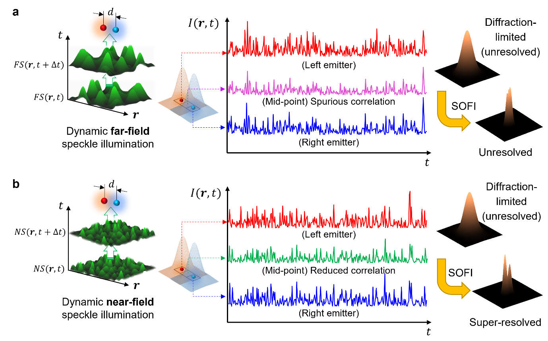
Fig. R1. Effect of subwavelength grain size of near-field speckle patterns on fluorescence fluctuation of two adjacent fluorophores.
We are deeply grateful to reviewer’s note on the mistakenly presented fluorescence fluctuation of two fluorophores exposed under dynamic far-field speckle illumination. By incorporating Fig. R1 in the revised Fig. 1., we hope to fix this error and to further clarify the description of excitation modality and the conceptual contrast of far-field and near-field speckle-illuminated scenarios. The full version of Fig. 1 is provided below:
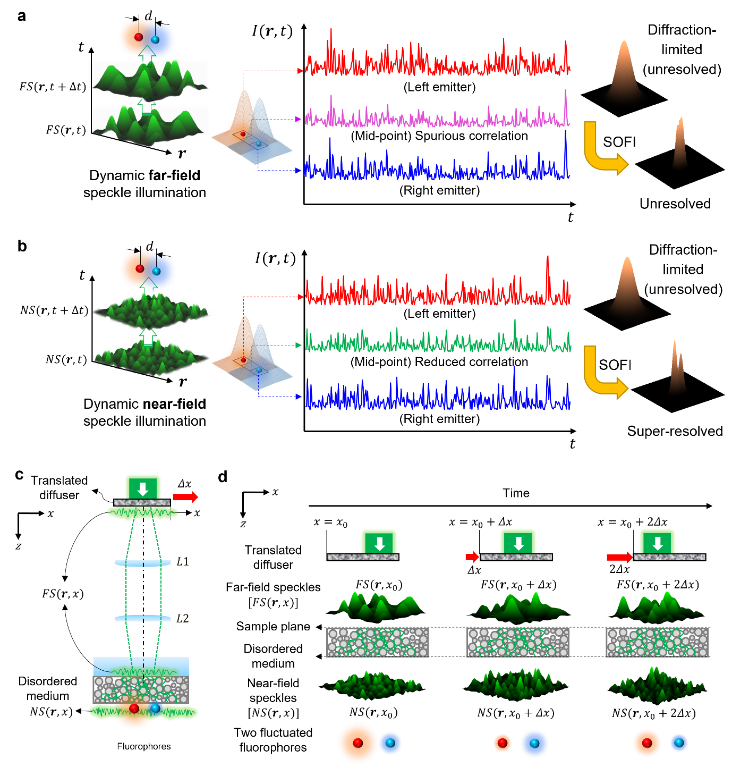
(Revised) Fig. 1. Dynamic near-field speckle illumination for NS-SOFI imaging experiment. a, b. Two independent fluorophores are assumed to be separated within subdiffraction distance under dynamic speckle illumination in the far- (a) and near-field (b). Examples of fluorescence intensity fluctuation trace I(r,t) measured during 300 frames of dynamic speckle illumination sampled at the locations of the two fluorophores and their midpoint. In contrast to far-field speckles (a), dynamic near-field speckle illumination (b) of subwavelength grain size produces independent fluctuation of two fluorophores favorable for SOFI processing. Here, the transparent Gaussian lobes assigned to each fluorophore represent the scale of the point spread functions of the base fluorescence detection imaging system. c, d Schematic representation of illumination optics to produce dynamic near-field speckle illumination. A pair of (pseudo-colored) red and blue sphere describes two independent fluorophores separated within subdiffraction distance under dynamic near-field speckle illumination. d Pictorial description of two-step scattering of a laser beam through the translated diffuser and turbid medium, which results in dynamic near-field speckle illumination at the sample plane (see Supporting Note S2 for details)
I(r,t)

R1.2. Methods for calibrating resolution of a 2D microscopy image in Fig. 2d and Fig. 4b.
R1.2.1. Reviewer 1’s comments to be addressed
The authors use line cuts through 2D images. These are often misleading. For example, in Fig. 2d it is much better to use a radial average. Similarly, in Figs. 4b, c and d it would be better to use vertical integration.

R1.2.2. Reply to R1.2.1.
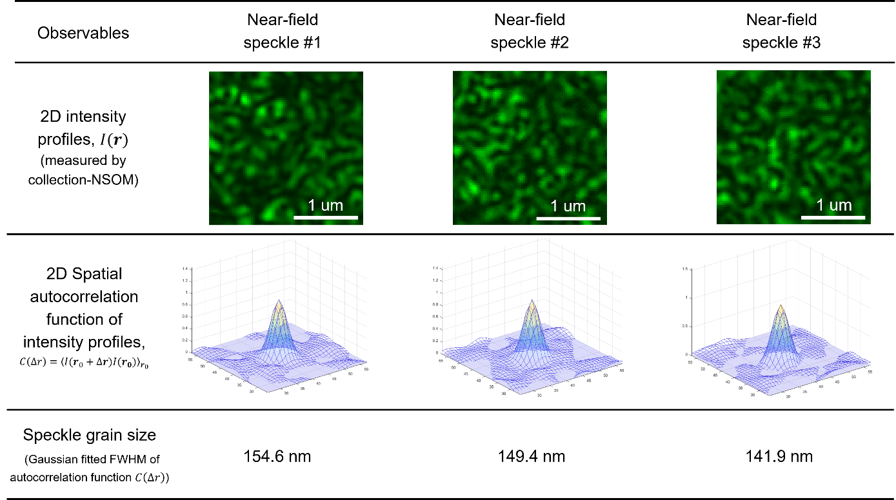
Fig. R2. Ensemble of near-field speckle patterns with speckle grain size close to 150 nm presented with their intensity statistics and two-dimensional spatial autocorrelations.
Fig. 2d calibrates the speckle grain size (spatial correlation length) by measuring the FWHM of the 1D cross-sectional intensity profile taken from spatial autocorrelation of near-field speckle intensity. To crosscheck that 1D cross-sectional intensity profiles provide the accurate estimates of the speckle grain size, as in Fig. R2., we performed two-dimensional Gaussian fits to spatial autocorrelation peaks calculated from the ensemble of near-field speckle patterns used in this study. In this manner, the autocorrelation is near-perfectly fit with two-dimensional (rotationally) symmetric Gaussian lobes, whose FWHM agrees well with the results presented in Fig. 2d.
Regarding Fig. 4b., we apologize for missing the cautions and alternatives of using line cuts and dip-visibility resolution criterion in the main text of our manuscript, which is already described in the Supporting Note S5 of our Supporting Information:

“Supporting Note S5. Caution regarding intensity-based dip-visibility resolution measurement in Fig. 4.
For each of the image in Fig. S4-d, the lateral resolution is determined as the separation between line pairs having dip visibility of 0.1 as inspected in the corresponding cross-sectional intensity profiles in Fig. 4e. However, determining image resolution solely via dip-visibility of line profiles need caution. The intensity-based resolution metric depends on the systematic noise, optical pixel size of the detection imaging system, and potential artifacts in the SOFI image processing. To minimize such error and to produce representative cross-sectional intensity profiles (Fig. 4e), more than 20 intensity profiles are taken in parallel to the dashed lines (denoted by ‘-’ in Fig. 4b-d) and then averaged. Next, we complement our intensity-based resolution measurement with the SEM image (Fig. 4a) for accurate distance calibration.”

The above underlined sentence in Supporting Note S5 remarks that lateral spatial resolution of Figs. 4b, c and d is already calibrated with vertically integrated line-cut intensity profiles. To provide reference to Supporting Note S5, we’ve added a remark at the end of the first paragraph following Fig. 3, as follows:

“Lateral spatial resolution of the resulting fluorescence images is calibrated as the minimum separation at which the dip visibility of a doubly-peaked cross-sectional intensity profile reaches 0.1, corresponding to about 20% dip with respect to the peak intensity (for the exact definition, see Section S4 in Supporting Information). Resolution gain is defined as the ratio of the distances that achieves dip-visibility of 0.1 before and after NS-SOFI processing. The cautions regarding line-cut based resolution calibration are noted in Supporting Note S5 in Supporting Information.”

R1.3. Why NS-SOFI achieves moderate resolution gain compared to similar variants of SOFI.
R1.3.1. Reviewer 1’s comments to be addressed
- While there is some increase in the present implementation relative to SOFI, it cannot really be regarded as a viable imaging system. Too much has been compromised for this moderate extra gain in resolution- a complex substrate, access only to the surface, a relatively complex excitation geometry (in transmission) etc. Since other methods employing SOFI in conjunction with spatially varying excitation such as SOFISM (SOFI + confocal) or SOFI-SIM (SOFI + structured illumination) as presented recently in Sroda et al. (Optica 7, 1308, 2020), in Zhao et al (Optics Letters 42, 3956, 2017) and especially in Descloux et al. (ACS Photonics 8, 2440, 2021) provide better resolution with less compromises.

- Why are the results so disappointing in terms of spatial resolution as compared to techniques mentioned above? What is the maximal expected resolution for a system with speckle grains of 150nm?

R1.3.3. Reply to R1.3.1.: a. NS-SOFI compared to similar variants of SOFI.
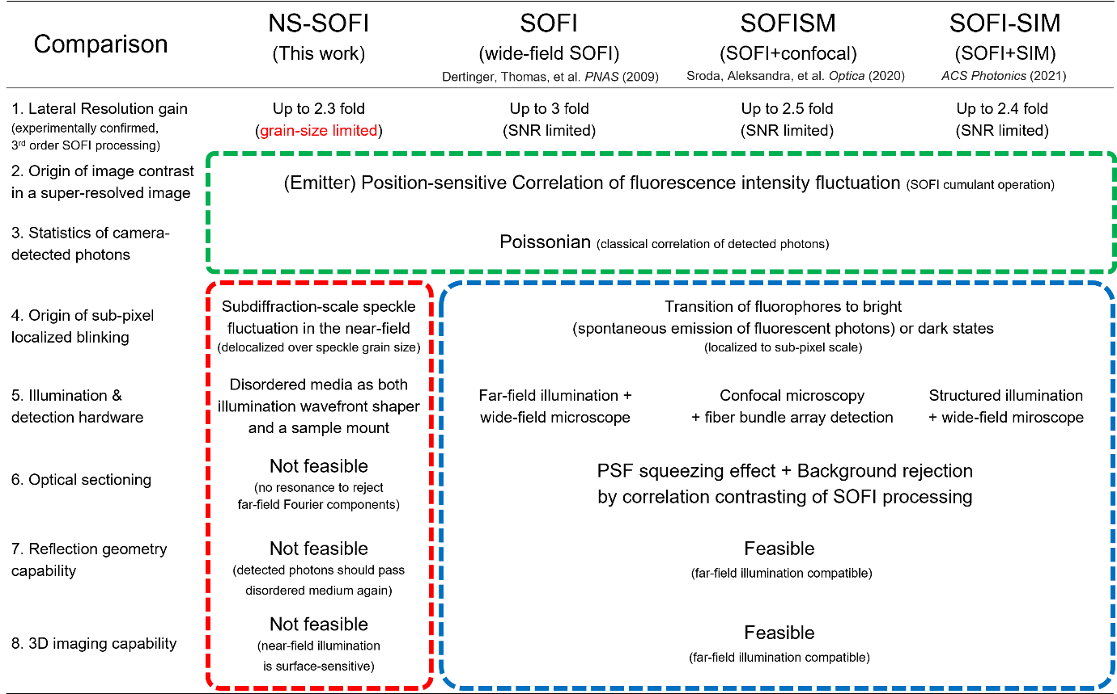
Fig. R3. NS-SOFI compared to similar variants of SOFI.
The crucial difference between our NS-SOFI and other variants of SOFI lies in the mechanism of inducing blinking fluorohphores. As reviewer 1 recommended, we’ve analyzed the recent variants of SOFI, such as SOFISM and SOFI-SIM together with conventional wide-field SOFI proposed by Dertinger, Thomas, et al. in 2009. These three variants of SOFI all rely on inherent blinking of fluorophores, where fluorophores, well approximated as atoms having three energy levels, have dual choices in the excited state either to relax directly into ground state by emitting fluorescent photons or through intermediate energy level without emission before relaxing to the ground state. This blinking mechanism is owing to the quantum energy levels of fluorophores and have no spatial dimension. Hence, the blinking mechanism is perfectly localized to the coordinate of the fluorophores with no spatial extent, which is a priori super-resolution information that can subsequently be retrieved by localization techniques or fluctuation microscopy (such as SOFI) etc.
On the other hand, NS-SOFI use dynamic speckle illumination in the near-field, which is shaped by a disordered substrate placed right below the fluorophores, to artificially induce their fluorescence fluctuation. As the blinking mechanism of NS-SOFI has spatial correlation length, quantitatively characterized by speckle grain size, dynamic speckle illumination inevitably imprints spurious spatial correlation to two fluorophores through excitation. This finite grain-induced correlation is the key issue addressed by employing near-field speckle patterns, which has substantially shorter grain size and approximates intrinsic blinking much better than dynamic far-field speckle illumination. This comes with the great cost of employing near-field speckle patterns, which limit effective volume of NS-SOFI to surface of the disordered substrate, become incompatible with reflection geometry, and lack 3D imaging capability as summarized in the red dashed rectangles in Fig. R3. This is in strak contrast to the advantages offered by intrinsic-blinking fluorophores listed in the blue dashed rectangles highlighting the advantages of three variants of SOFI techniques. Being aware of this shortcomings, and regarding this as our next motivation to propose a new version of NS-SOFI, please refer to the R1.3.4 of this response letter that suggests a more viable form of NS-SOFI.

R1.3.3. Reply to R1.3.1.: b. Why NS-SOFI achieves moderate resolution gain compared to similar variants of SOFI.
R1.3.3.1. The map of NS-SOFI research to analyze the realistic issues behind the disappointing NS-SOFI resolution as compared to conventional blinking-fluorophores-based SOFI.
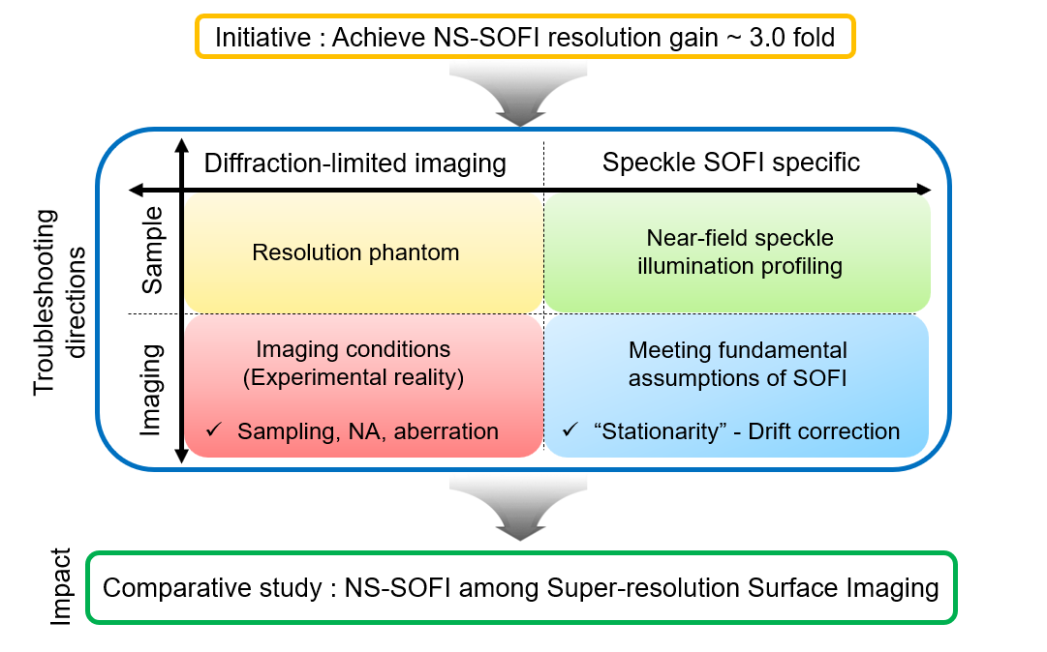
Fig. R4. Map of NS-SOFI research that categorizes the practical issues impeding ideal NS-SOFI-based super-resolution in the realistic fluorescence microscopy setting.
As suggested in the initiative of Fig. R4., though SOFI theory predicts three-fold enhancement of spatial resolution via 3rd order SOFI cumulant operation followed by Fourier reweighting procedure, the actual resolution gain obtained after application of NS-SOFI technique in the realistic fluorescence microscopy setting is limited by the signal-to-noise ratio (SNR) of the acquired fluorescence images and potential artifacts caused by SOFI processing. To clearly reveal how the practical issues affect the final resolution of NS-SOFI images, Fig. R4 provides a perspective that categorizes the experimental factors in NS-SOFI imaging experiment, all of which should be tackled and optimized to acquire the best resolution gain possible by NS-SOFI technique. Hence, we reply to reviewer #1’s comment R1.3.1 in step-by-step fashion to clarify the complex interplay of every factor considered for the best NS-SOFI imaging performance. We begin with an ideal scenario where NS-SOFI is expected to truly approximate the SOFI applied to intrinsically blinking two fluorophores. Next, we describe four issues to be optimized in the real NS-SOFI imaging experiments: resolution phantom, imaging conditions, near-field speckle illumination intensity profiling, and stationary assumption.

R1.3.3.2. Summary of three ideal scenarios where S-SOFI truly approximates the performance of SOFI based on intrinsically blinking fluorophores.
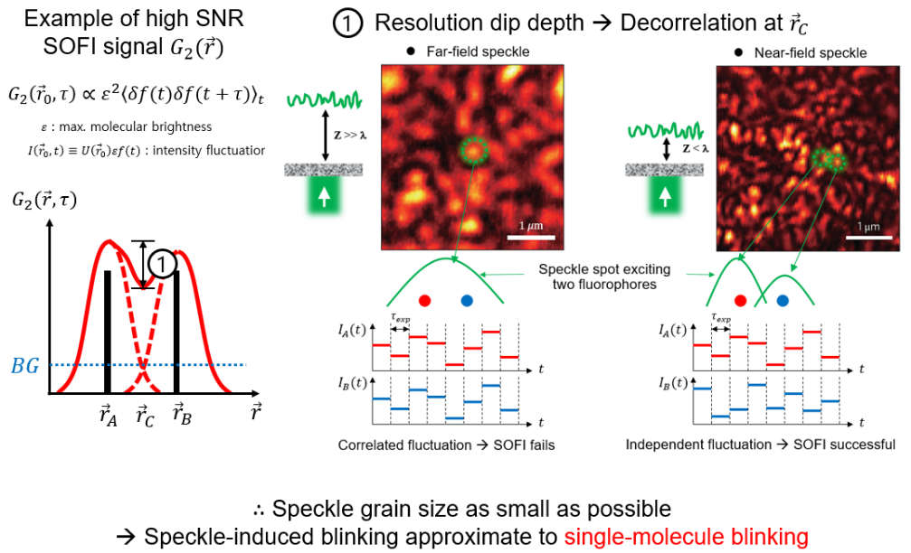
Fig. R5. Resolution dip depth determined by decorrelation of two superposed intensity fluctuation of two fluorophores under dynamic speckle illumination.
Fig. R5. presents the key hypothesis of our paper that, as speckle grain size gets smaller, the resulting speckle-induced fluorescence fluctuation of two fluorophores within subdiffraction distance becomes more mutually independent and thus approximates intrinsic blinking of fluorophores promising to bring forth the full super-resolving power of SOFI processing. As this hypothesis is fully discussed in our manuscript, we proceed to the next conditions to be met for ideal NS-SOFI imaging performance.
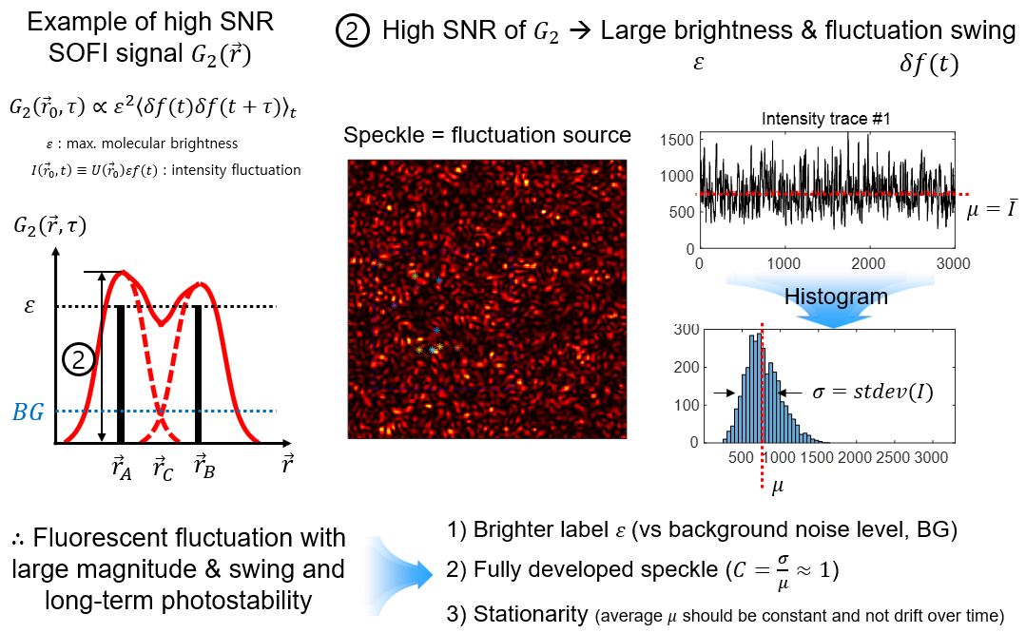
Fig. R6. Requirements for high SNR of SOFI signal presented with the example of 2nd order SOFI cumulant operation.
As the image contrast rendered by SOFI cumulant operation is essentially a statistical ensemble average performed with the second- or third-order statistics of the fluorescence intensity fluctuation, a high SNR SOFI signal above the background level is obtained only if the following conditions are met, as shown in Fig. R6.:
- The brightness of fluorophores determines the absolute magnitude of the SOFI signal.
- Fluctuation swing, i.e., the difference between fluctuating intensity contrast and its stationary mean should be large enough to reveal information of higher-order intensity fluctuation statistics above the noise level.
- The mean of the intensity fluctuation should be stationary, as the spurious drifting or moving average biases the intensity fluctuation over the entire acquisition time and contaminate the intensity fluctuation statistics purely from fluorophore fluctuation.
As NS-SOFI relies on dynamic speckle illumination to induce fluorescence fluctuation of the fluorophores, the speckle patterns themselves need to be fully developed such that its speckled intensity contrast should be comparable to its average intensity level, where the latter just act as a wide-field flat-field illumination. If speckle patterns are under-developed, fluorophores are mostly excited by the average level of the illumination intensity, and the imaging situation just becomes the fluorescence imaging under wide-field flat illumination. Therefore, it is crucial to develop a means of in-situ profiling the intensity of dynamic near-field speckle illumination to check whether it is fully developed or not. This issue will be further discussed later in this response letter.
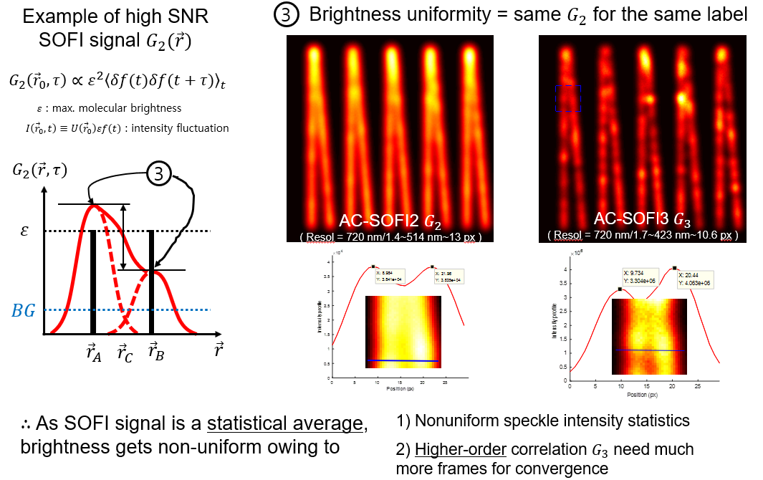
Fig. R7. Undesired scenario where the SOFI signals of two emitters are not symmetric in their magnitude and thus fail to super-resolve them.
In many cases, the brightness of the labeled fluorophores is not always identical even though we use the same species of fluorophores for a single run of NS-SOFI imaging experiments. As shown in Fig. R7, if the brightness of two emitters differ by substantial amount, the SOFI contrast of lower-brightness emitter is nonlinearly underestimated as compared to that of higher-brightness emitter, such that resolution dip between SOFI contrast of two emitters is crushed and thus becomes invisible. Plus, in contrast to the conventional SOFI relying on the intrinsic blinking of fluorophores, non-uniform speckle intensity levels at different locations of emitters can modulate the effective brightness of the fluorophores as the final signal level of the intensity fluctuation is linearly multiplied by the speckle excitation intensity. Lastly, SOFI processing higher than the 3rd order needs much more frames to yield a converging SOFI signal. If there are no sufficient frames for convergence, a higher-order SOFI signal tends to be highly oscillating depending on the total number of used frames, which is a difficult situation to distinguish from the degrading SOFI signal owing to non-unifiorm brightness of fluorophores.

R1.3.3.3. Practical issues that determine the final SNR and resolution of the NS-SOFI image: 1) Resolution phantom(templates) used to calibrate the experimental resolution.
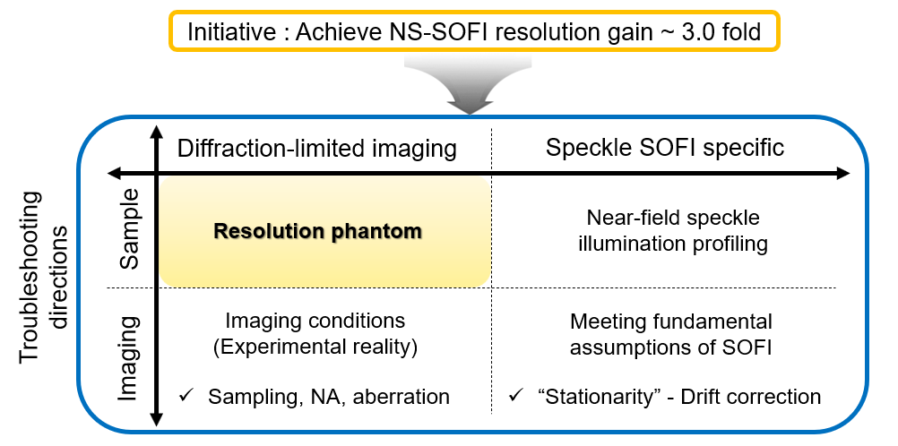
Fig. R8. The type of resolution phantom, which is used for calibrating resolution of NS-SOFI imaging, adds a layer of difficulty when realizing ideal NS-SOFI performance.
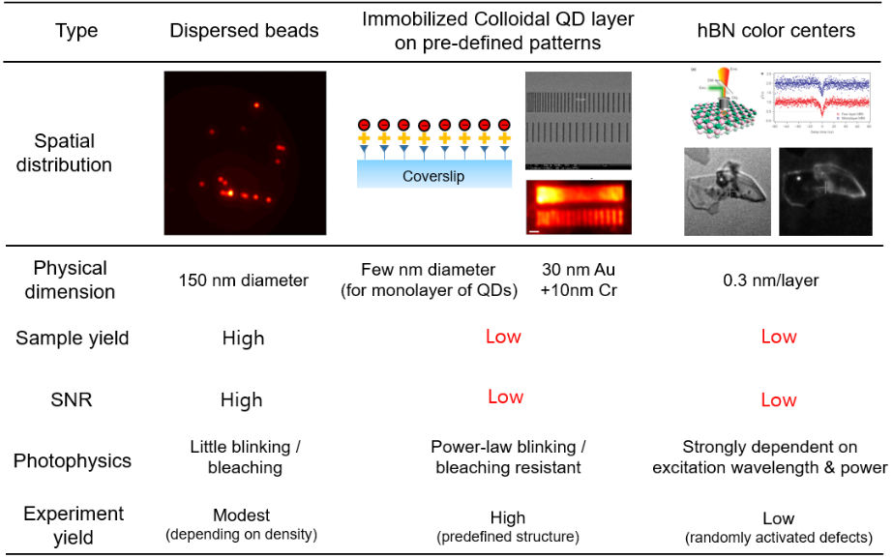
Fig. R9. Three types of experimental resolution phantoms to evaluate the lateral spatial resolution of NS-SOFI images.
Fig. R9 suggests three types of experimental resolution phantoms that provide the spatial arrangement of multiple bright fluorophores advantageous for calibrating the lateral resolution of two-dimensional diffraction-limited fluorescence and NS-SOFI images. Typically, randomly dispersed fluorescent beads are most readily prepared templates and offer high SNR fluorescence signals. However, as the sample preparation depends on solution processing of colloidal microparticles (the density of fluorescent beads in solution is only controlled), it is laborious to seek the pairs of fluorophores separated by the desired distance to be super-resolved by the NS-SOFI technique. In addition, line-cut profiling of doubly peaked intensity profiles should be performed over the multiple pairs of fluorophores to ensure reliable resolution calibration, which makes the task of calibrating resolution with fluorescent beads much demanding. This is the reason behind relatively modest (NS-SOFI imaging) experiment yields in Fig. R9. We have used fluorescent beads to calibrate the absolute resolution possible with 150 nm speckle grain size, as summarized in Fig. 5.
On the contrary, pre-defined patterns of colloidal quantum dots functionalized on the coverslip provides the most intuitive measure of lateral spatial resolution in an experimental situation. In Fig. 4, we have calibrated the resolution gain of the NS-SOFI technique by inspecting the pair of FIB-milled lines resolved before and after NS-SOFI processing. In general, expertise with colloidal chemistry is needed to immobilize a monolayer of colloidal quantum dots on the coverslip. Hence, the sample yield of this pre-defined pattern sample is relatively low but worth trying because this sample enables quantitative evaluation of resolution gain.
Regarding the color centers in mono- or multilayers of two-dimensional hexagonal boron nitride materials, there is a surge of interest and a plethora of techniques to deterministically activate a large array of these artificial quantum emitters. However, it is difficult to inspect the true location of these color centers, which are mostly lattice vacancies to be resolved with atomic resolution such as scanning tunneling microscopes. Though this sample is not amenable to complementary resolution calibration via electron microscopes, we have suggested as the last resolution phantom as our NS-SOFI can offer wide-field super-resolution alternative to the conventional confocal microscopy typically used to obtain the spatial map of optically activated color centers.

R1.3.3.4. Practical issues that determine the final SNR and resolution of the NS-SOFI image: 2) Diffraction-limited fluorescence imaging conditions (sampling, numerical apertures, and aberrations, etc)
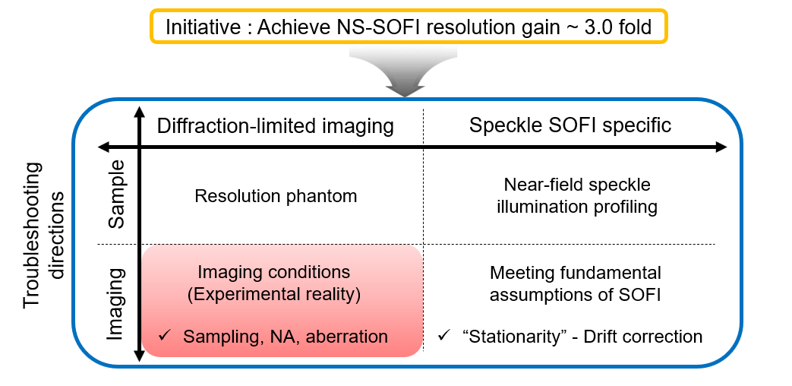
Fig. R10. Diffraction-limited imaging conditions such as sampling, NA, and aberrations are experimental reality to be optimized before SOFI processing.
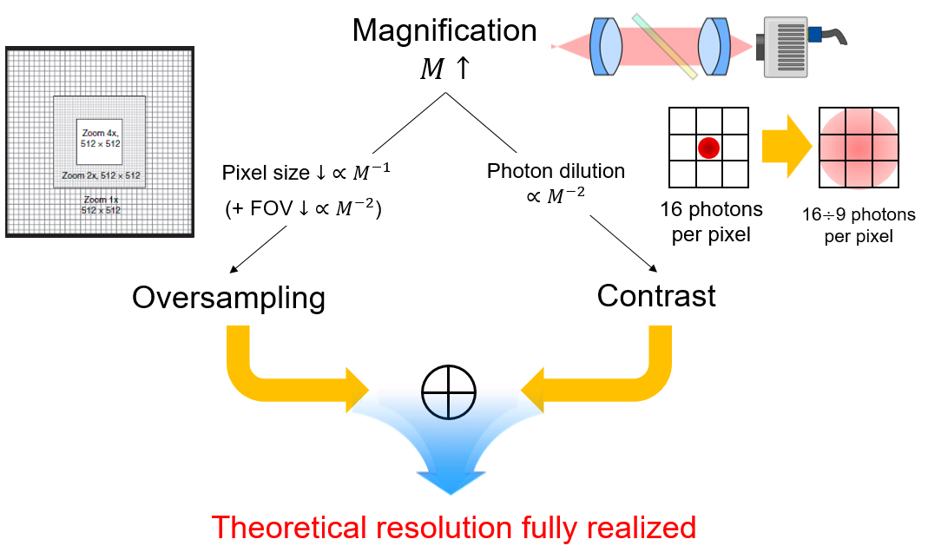
Fig. R11. Visualized description on how the sampling (as the result of magnification and CCD digital grid) affects the final fluorescence image resolution.
The optical pixel size determined by magnifying telescopes is crucial for the digital representation of fluorescence image to faithfully deliver its analog information without loss of information. Hence, the magnification of detection imaging system should be carefully optimized to oversample the target spatial resolution to prevent digitization-induced loss of the ideal theoretical resolution. Furthermore, physical magnification via telescope entails photon dilution effect: large magnification spreads signal photons over much larger area of CCD pixels and results in degrading SNR of fluorescence images as there are constant levels of background noise levels in CCD camera. In this section, we want to discuss how we optimized our optical pixel size (physical pixel size of the camera demagnified by the total magnification of the imaging system) to yield ideal NS-SOFI imaging results.
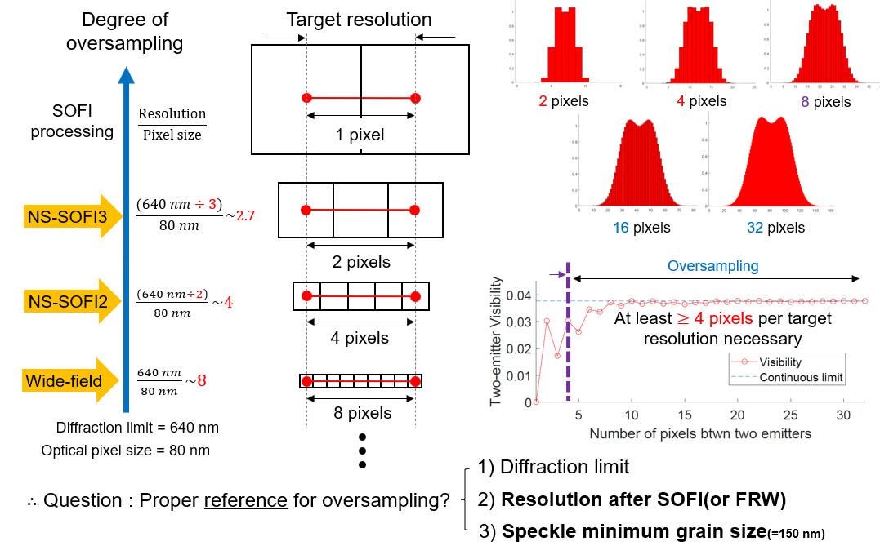
Fig. R12. Establishing the reference length-scale for oversampling based on two-emitter dip visibility criterion.
In general, it is always desired to oversample the target spatial resolution with as many pixels as possible, but this causes significant photon dilution at each CCD pixel and lowers the SNR of the acquired fluorescent images. In other words, the tradeoff with magnification comes with the fact that the fluorescent photon budget should be distributed over the CCD pixels in the limit that our oversampling assures enough SNR of the diffraction-limited images for SOFI processing. In Fig. R12, the digitized fluorescent images of doubly peaked intensity profiles of a pair of fluorophores are presented as a function of the number of pixels sampling the separation between two emitters. For our digitized grid to approximate the continuum limit, i.e., infinite pixels between two emitters, our desired resolution distance should be oversampled with at least 4 or 6 pixels to reproduce reliable two-emitter dip visibility.
Regarding the NS-SOFI, where fluorescence fluctuation is rendered by speckle illumination of finite spatial correlation length (speckle grain size), we face the question of which characteristic length scales-diffraction limit, target SOFI resolution, speckle grain size-should be used for oversampling. This issue is critical and specific to NS-SOFI, as further demonstrated with two scenarios representing the under-sampled (Fig. R13) and over-sampled situations (Fig. R14).
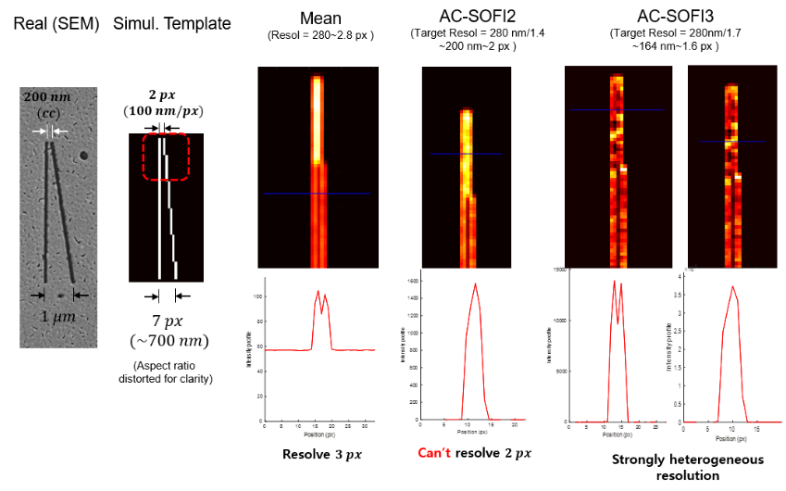
Fig. R13. When the target NS-SOFI resolution, 200 nm at the tip of two diverging lines, is under sampled with only two pixels, a SOFI autocumulant (labeled as AC-SOFI) cannot resolve the 200 nm filament separation at the top, even though the theoretical resolution of SOFI guarantees to resolve the 200 nm when the assumed diffraction limit is 280 nm.
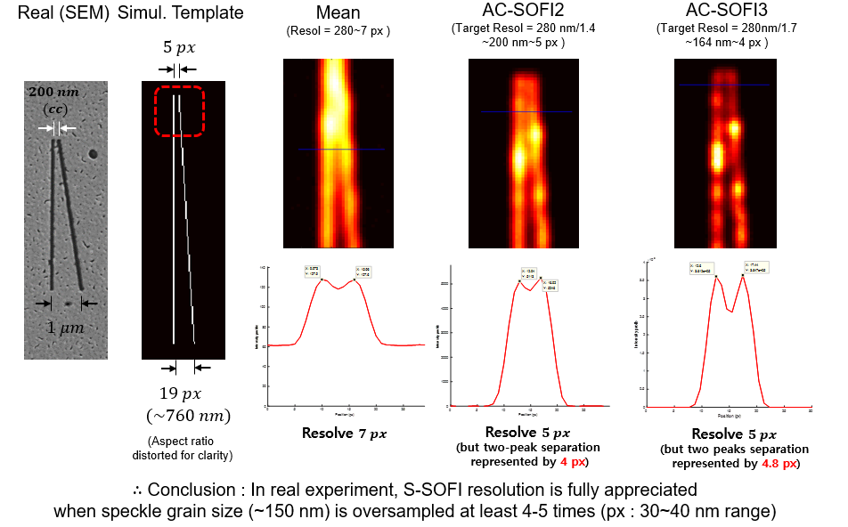
Fig. R14. When the target NS-SOFI resolution, 200 nm at the tip of two diverging lines, is oversampled with five pixels, a SOFI autocumulant (labeled as AC-SOFI) faithfully resolve the 200 nm filament separation at the top, at the expense of digitization.
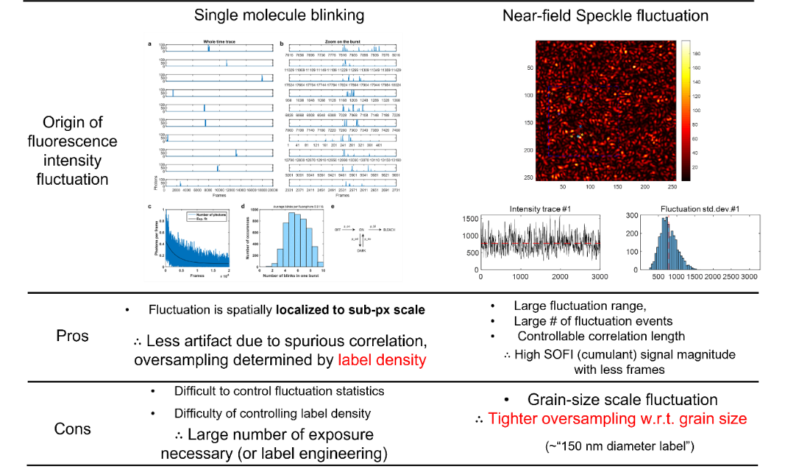
Fig. R15. Stricter oversampling requirement posed on NS-SOFI as compared to conventional SOFI relying on single molecule blinking.
Hence, from the contrasting scenarios in Fig. R13 and Fig. R14, we conclude that the oversampling requirement for NS-SOFI should be defined by the speckle grain size, not diffraction limit, as shown in Fig. R15. This is because the mechanism inducing fluorescence fluctuation has a finite correlation length, which is the speckle grain size in dynamic speckle illumination. On the other hand, conventional SOFI relying on single-molecule blinking, which is sub-pixel localized, is free of this oversampling requirement. We summarize this concousion in Fig. R15 and provide the comparison table of oversampling methods employed to optimize the optical pixel size and SNR of the NS-SOFI image stack in Fig. R16.
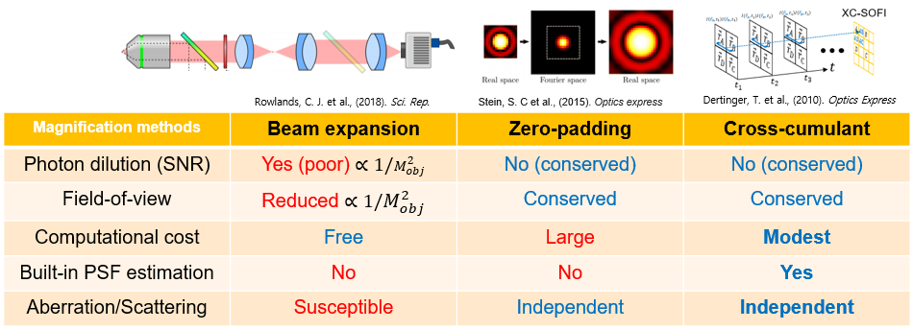
Fig. R16. Physical and computational oversampling methods in comparison. All of these techniques are employed to produce NS-SOFI images.

R1.3.3.5. Practical issues that determine the final SNR and resolution of the NS-SOFI image: 3) Meeting stationary fluctuation requirement for SOFI processing by drift compensation.
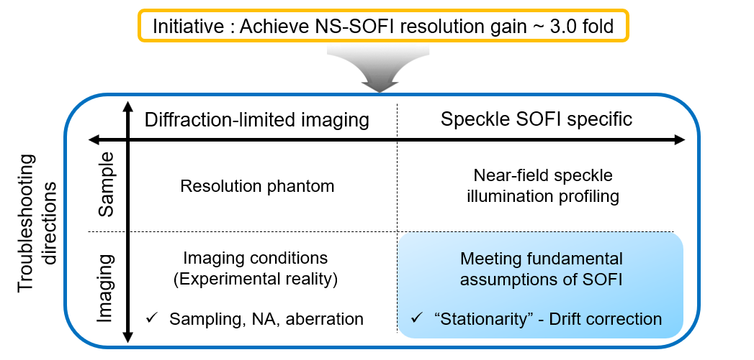
Fig. R17. Need for axial and lateral drift compensation to meet stationarity requirements for SOFI-processed fluorescence intensity fluctuation.
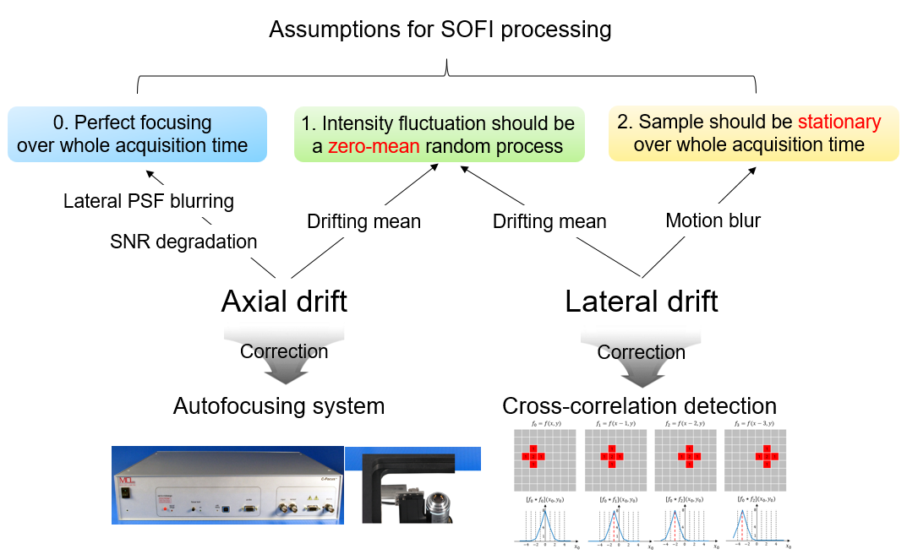
Fig. R18. The three requirements for acquiring ideal stationary intensity fluctuation potentially contaminated by axial and lateral drift.
As in Fig. R18, axial or lateral drift during the long-term acquisition of blinking fluorescence image stack are detrimental factors that contaminate the final NS-SOFI images and become significant sources of artifacts amplified with SOFI cumulant processing. To compensate this loss, autofocusing system and cross-correlation detection via a sub-pixel registration algorithm are necessary to pre-condition the image stack before SOFI processing.
Below, we present a visual summary of the symptoms and correction procedure for these drift phenomena in Fig. R19-R22.
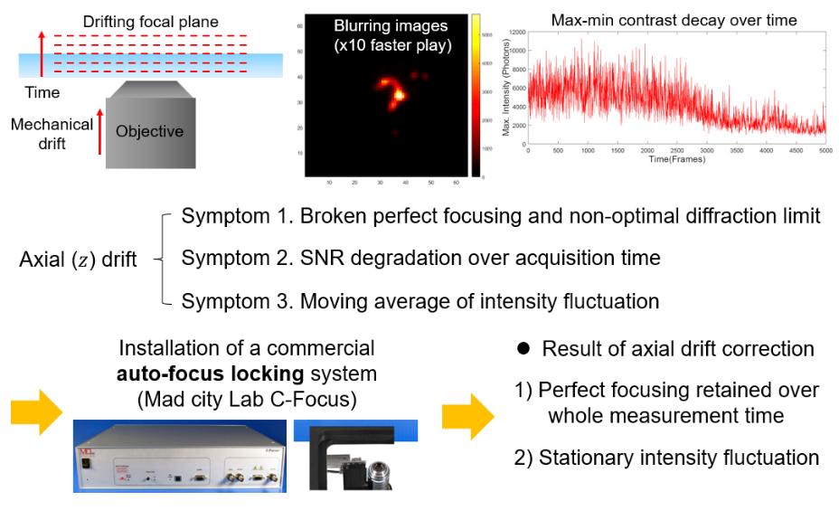
Fig. R19. Detrimental effects of axial drift on acquired image stack monitored by (max – min) signal contrast decay over entire acquisition time. Auto-focus locking system is implemented to cure this axial drift and thus to ensure stationary fluctuation.
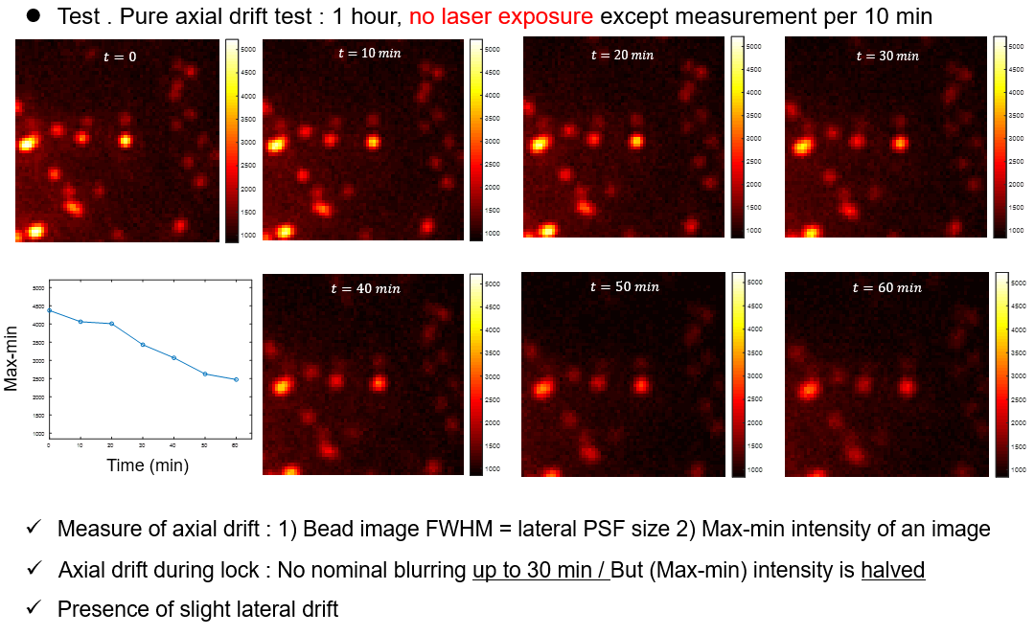
Fig. R20. An example of how axial drift breaches stationary assumption every ten minutes of diffraction-limited fluorescence image acquisitions.
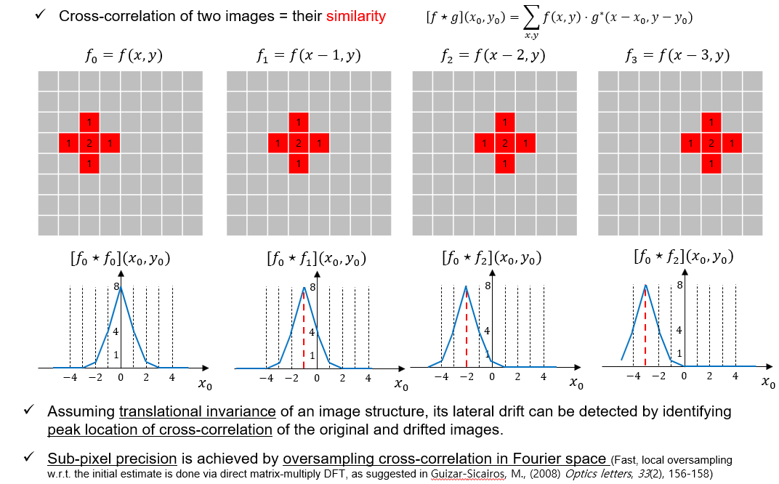
Fig. R21. Illustration of the lateral drift correction by cross-correlation detection implemented in sub-pixel registration algorithm.
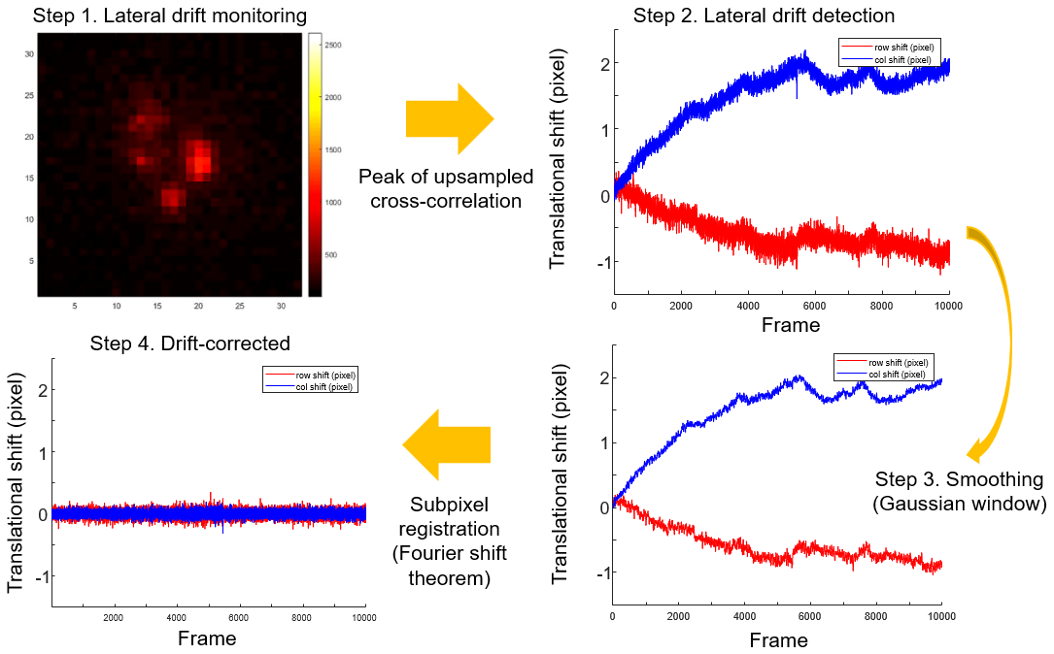
Fig. R22. The lateral drift correction procedure with the sub-pixel registration algorithm suggested in Fig. R21.
R1.3.3.6. Practical issues that determine the final SNR and resolution of the NS-SOFI image: 4) Need for in-situ near-field speckle intensity profiling methods without NSOM.
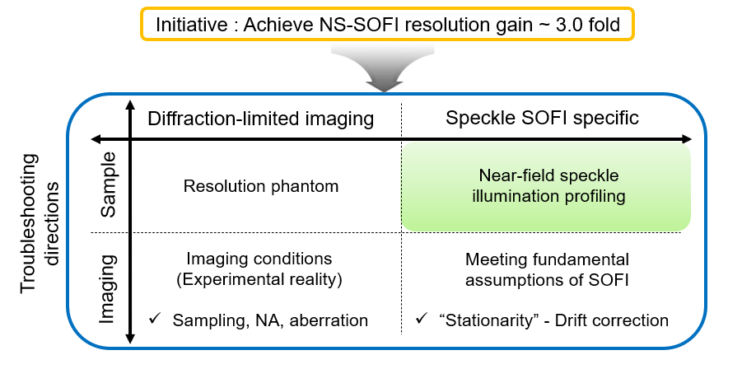
Fig. R23. Need for in-situ profiling of near-field speckle intensity.
As the last experimental factor that affects final NS-SOFI performance, intensity profiles of dynamic near-field speckle patterns should be probed with direct, in-situ methods other than near-field scanning optical microscopes(NSOM), which cannot be adapted in the current NS-SOFI imaging setup.
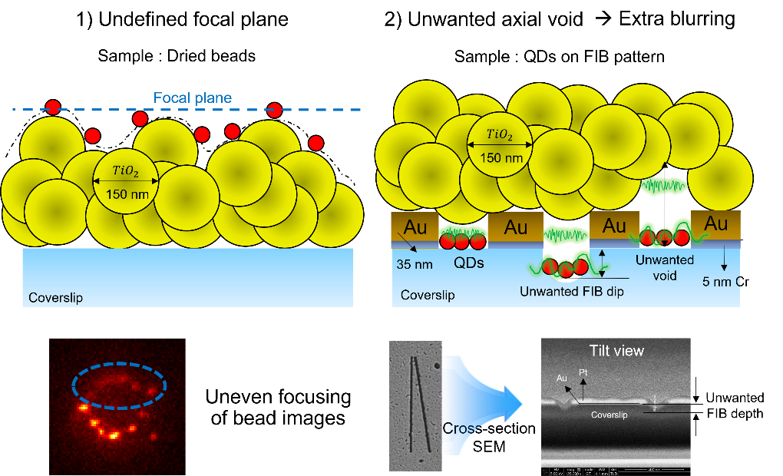
Fig. R24. Failure scenarios for NS-SOFI imaging with fluorescent beads (left) and ruler-arranged quantum dots (right). These hypothetical situations are unavoidable with our disordered substrates.
Fig. R24 depicts two hypothetical scenarios potentially leading to the failure of the NS-SOFI-based super-resolution imaging. For instance, our disordered substrate composed of 3D random distribution of dielectric nanoparticles has highly uneven surface topography at the sample plane, as evidenced by uneven focusing of fluorescent beads situated in the same field-of-view, which was occasionally problematic before acquiring the results in Fig. 5. In the case of quantum dots on ruler patterns in Fig. 4, focused ion beam(FIB) milling can etch unwanted depth below the surface of the coverslip, resulting in extra propagation length and blurring of the near-field speckle patterns to lose its subwavelength evanescent Fourier components.

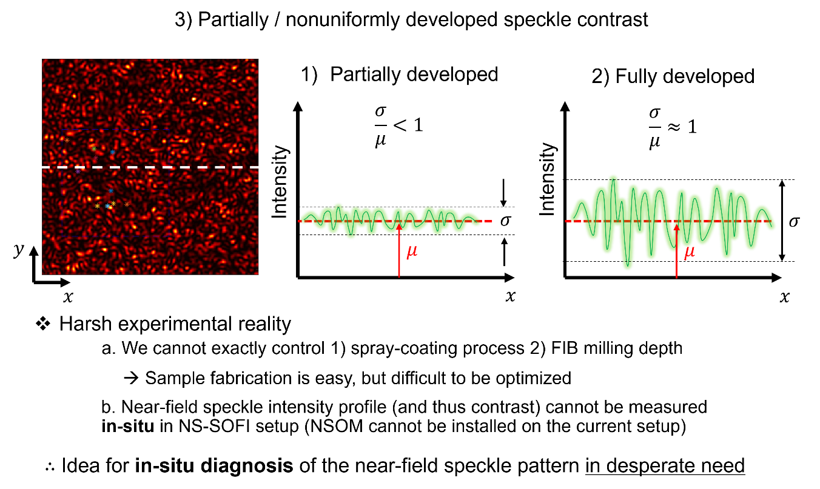
Fig. R25. Why in-situ profiling of near-field speckle patterns other than NSOM is needed.
The unwanted scenarios suggested in Fig. R24 is difficult to notice as we cannot install a NSOM system in NS-SOFI imaging setup to check whether desired dynamic near-field speckle illumination is produced. For any super-resolution imaging modality relying on structured or random illumination, exact profiling of their illumination intensity profiles is crucial to optimize the illumination optics and diagnose potential artifacts arising from the combination of distorted illumination profiles and SOFI-based computational processing. We propose an indirect in-situ near-field speckle profiling methods with dSTORM, as schematically suggested in Fig. R26, though we could not implement owing to lack of our chemical expertise to immobilize a monolayer of colloidal quantum dots on the coverslip without aggregation.

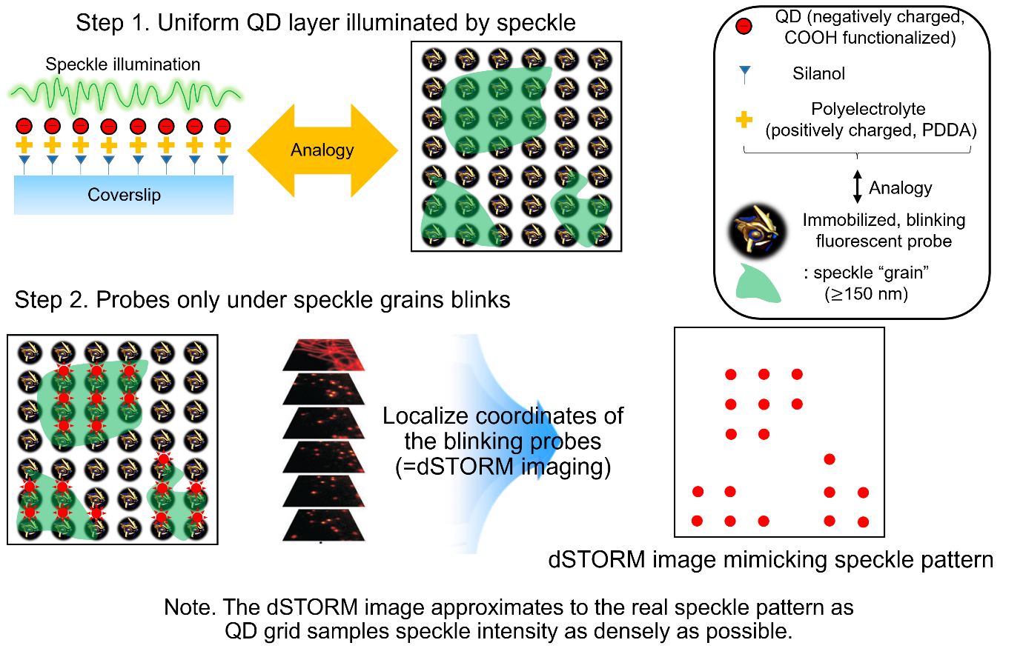
Fig. R26. Proposal for profiling near-field speckle intensity in NS-SOFI imaging setup with a calibration sample made of a uniform lattice of colloidal quantum dots and dSTORM imaging.

R1.3.3.7. Practical issues that determine the final SNR and resolution of the NS-SOFI image: 5) Visual summary of the practical resoluting limiting factors in NS-SOFI imaging experiments.
To sum up and visualize the complex factors affecting the final resolution of NS-SOFI images, we provide a visual chart of how each observable in the NS-SOFI imaging system is calibrated (Fig. R27-28), monitored (Fig. R29), affect the SNR of the image stack (Fig. R30, 31), and the final SNR of NS-SOFI image (Fig. R32) without lengthy description.
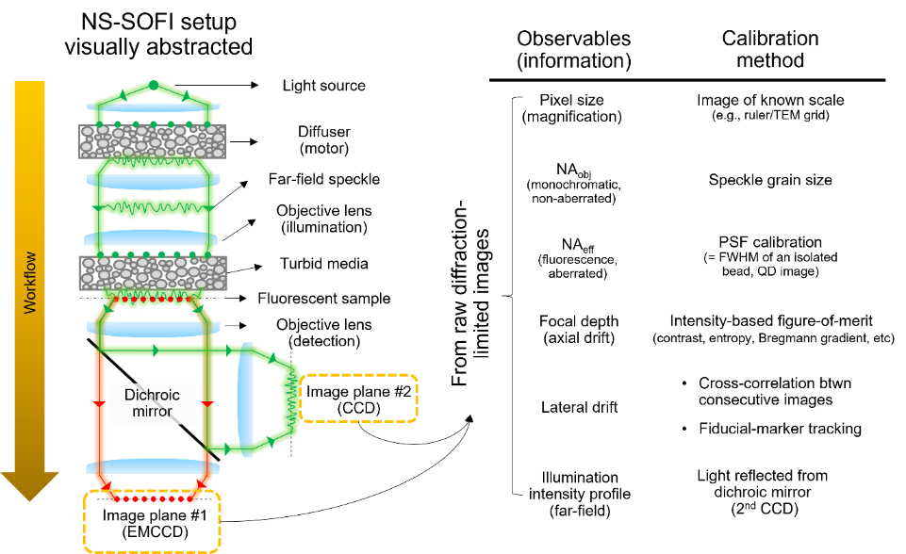
Fig. R27. Direct observables in NS-SOFI imaging configuration and their corresponding calibration methods.
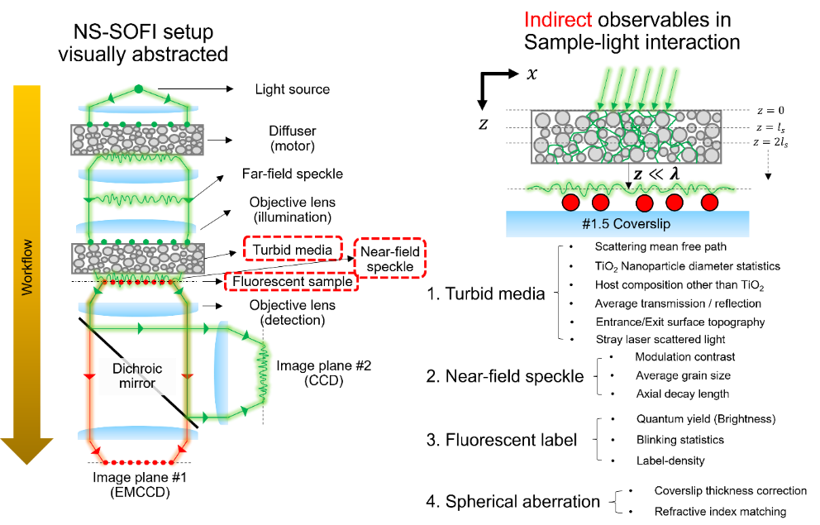
Fig. R28. Indirect observables that is difficult to be assessed directly in practice.
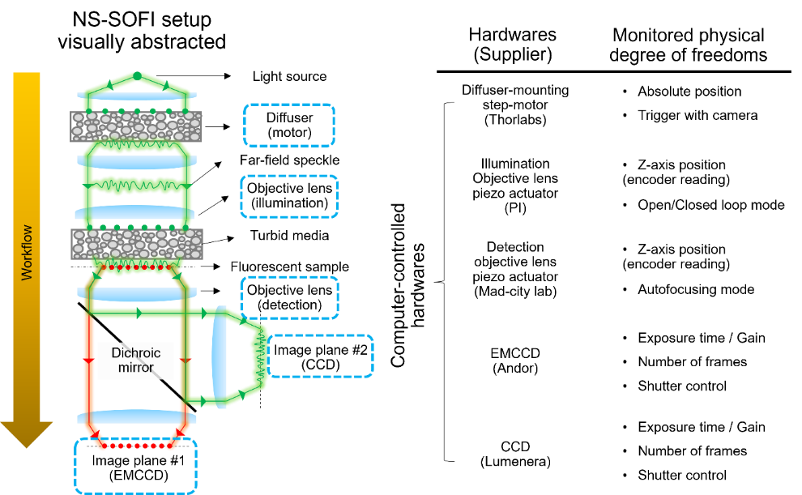
Fig. R29. Hardware to control and monitor each degree of freedom in NS-SOFI imaging experiment.

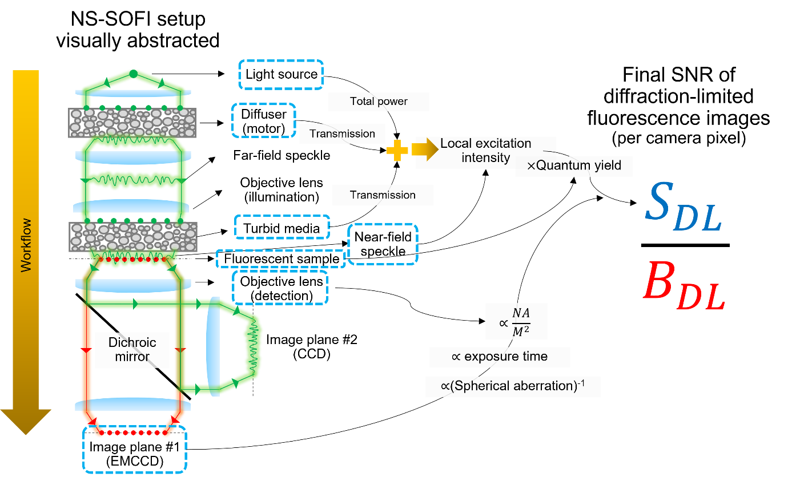
Fig. R30. How each imaging component affects the final SNR of the diffraction limited (denoted as DL) image stack.
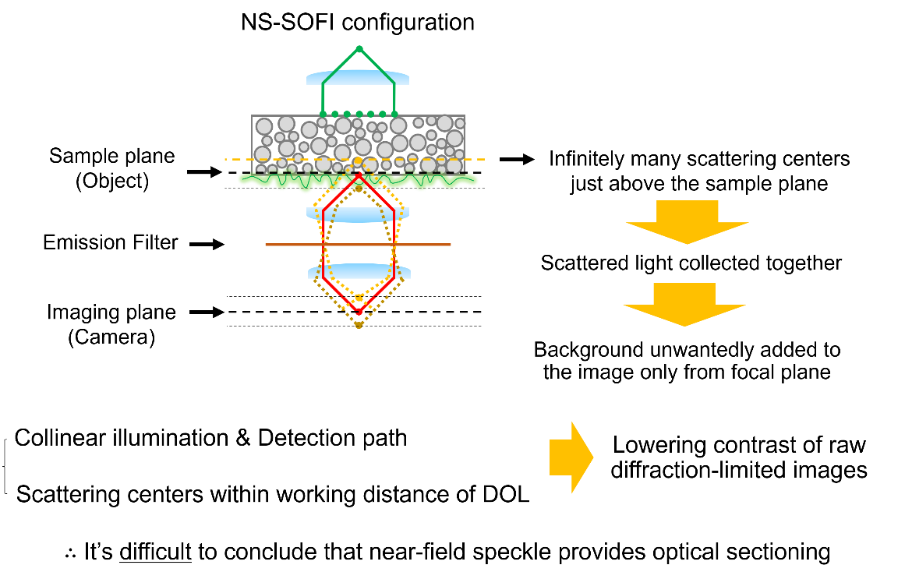
Fig. R31. Deteriorating SNR owing to lack of optical sectioning inherent in the current disordered substrate for NS-SOFI imaging experiment.
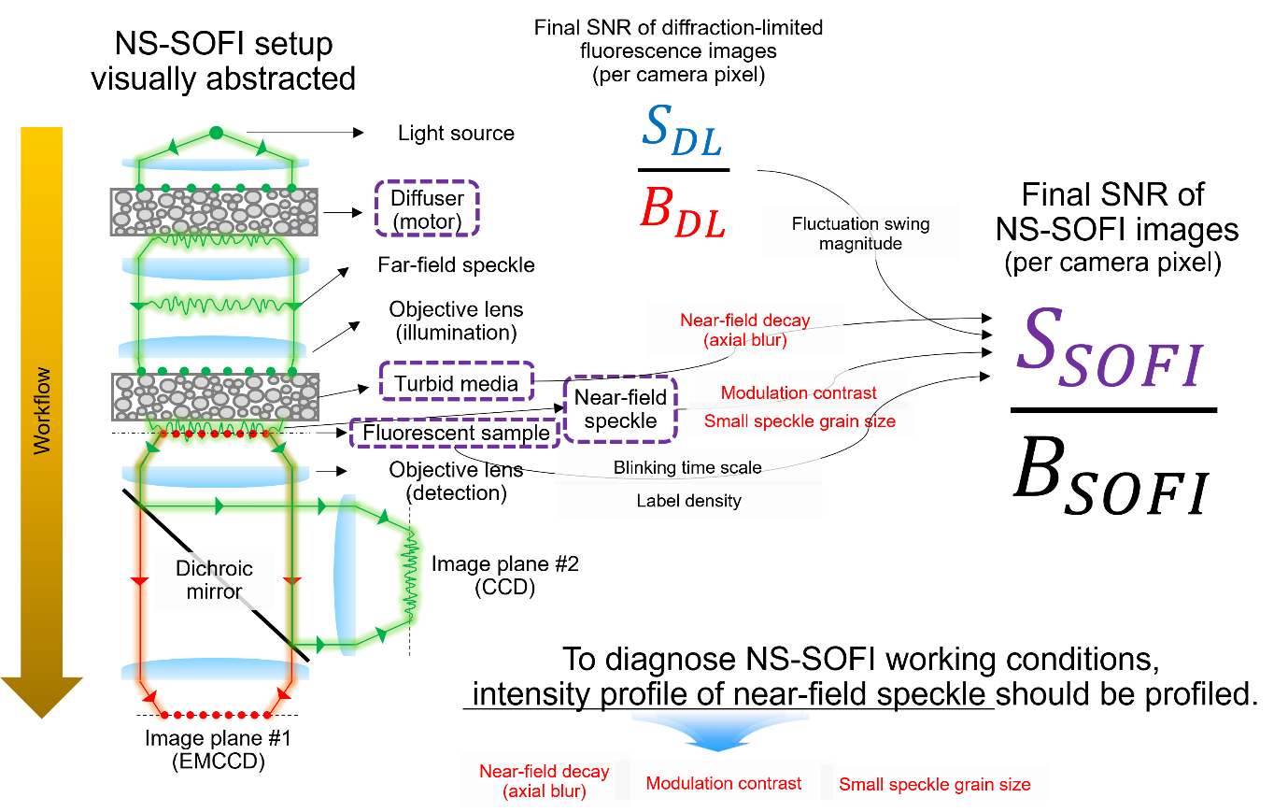
Fig. R32. How each imaging component affects the final SNR of the super-resolution NS-SOFI (denoted as SOFI) images.

R1.3.4. Reply to R1.3.1.: c. A proposal for a more viable form of the NS-SOFI: Chipscopes
R1.3.4.1. Practical difficulties with disordered substrates composed of 3D random arrangement of dielectric nanoparticles for NS-SOFI imaging experiments.
As detailed in Section R1.3.3., the present configuration of NS-SOFI with disordered nanoparticles has many disadvantages to be practically viable super-resolution imaging system, as reviewer #1 pointed out. To resolve this issue, we propose a new version of NS-SOFI illumination hardware, which can be pursued as a future research topic. First, we provide a visual summary of the inherent practical difficulties with the current configuration of NS-SOFI.
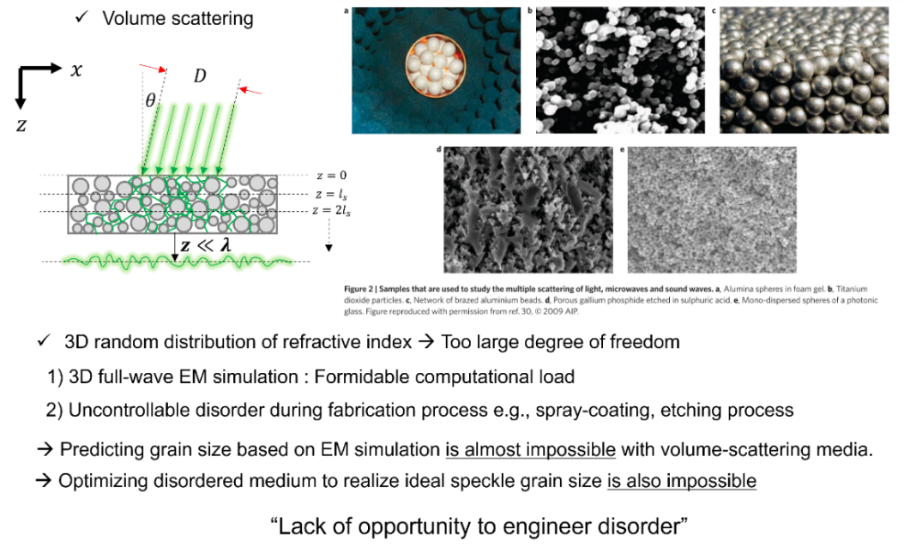
Fig. R33. Lack of opportunity to engineer and simulate disorder with disordered substrates made of 3D random distribution of dielectric nanoparticles.
Fig. R33 summarizes the crucial hurdles to impede the practical application of NS-SOFI. Our current disordered substrates composed of 3D random stacked dielectric nanoparticles are at the center of this practical issues. Too large degree of freedom makes it formidable to simulate light propagation inside the disordered media, we cannot predict whether we can get near-field speckle patterns with desired grain size even in the computational setting. In addition to this blindness to computational prediction, fabrication methods such as spray-coating and chemical etching cannot control the statistical parameters characterizing the structural disorder of our substrates. Hence, we have no means of optimizing speckle grain size at hand.
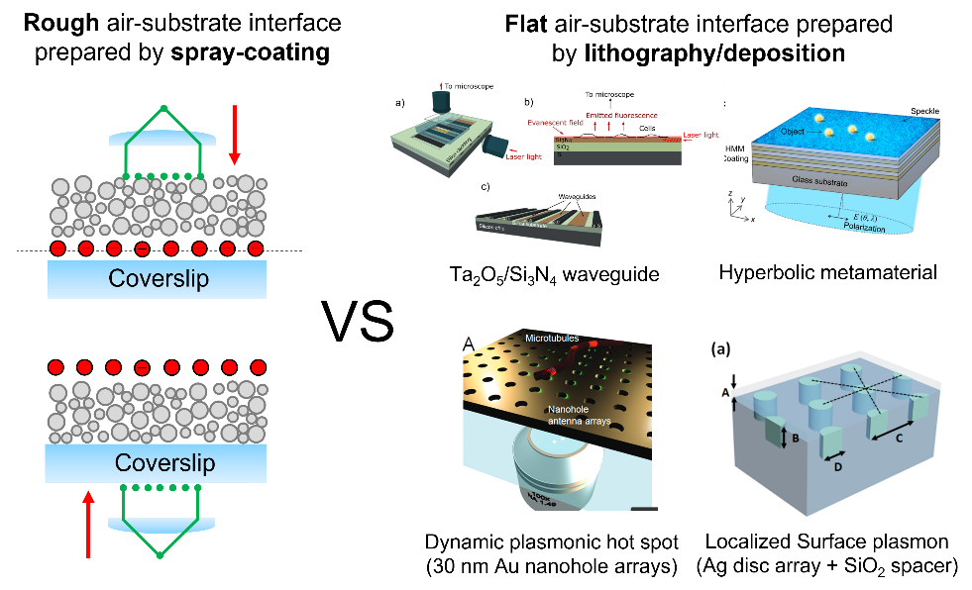
Fig. R34. Comparing our disordered substrates for NS-SOFI imaging and other near-field structured illumination platforms.
It is worth comparing our disordered substrate as near-field random illumination shaper with other platforms, as exemplified in Fig. R34. Waveguide leaky modes, hyperbolic metamaterials, dynamic plasmonic hot spots, and localized surface plasmons are extensively exploited to achieve super-resolution with the near-field structured illumination. All of these surface-sensitive platforms provide planar surface topography as the results of a sophisticated nanofabrication process, while our disordered substrates introduce surface roughness as the result of the quick-and-easy spray-coating procedure. Also, it is difficult to modify the surface chemistry of the disordered substrate and thus perform imaging with biological specimen.

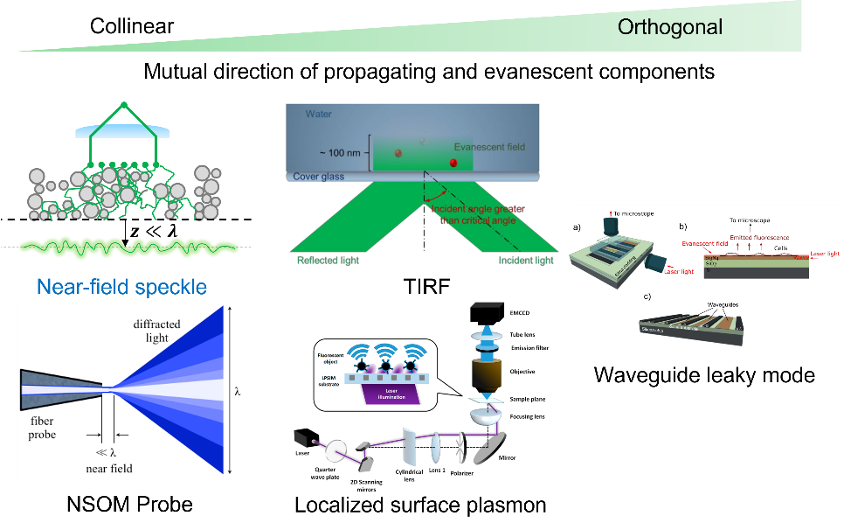
Fig. R35. Example of super-resolution microscopes grouped by relative direction of illuminating beam and detection axis. As the illumination and detection axes gets mutually orthogonal, we can prevent the background composed of unfiltered illumination photons to be detected with fluorescent signals and thus achieve high SNR of fluorescence images.
In terms of boosting fluorescence image SNR, it is always recommended to reject illumination photons to be co-detected with fluorescence photons. For instance, total-internal-reflection fluorescence microscopy (TIRF) and localized surface plasmon structured illumination microscopy (LPSIM) achieves evanescent sheets of the near-field structured illumination by rejecting propagating incident beams with spatial mode-matching conditions. While the incident beam direction is inclined with respect to the axis of the detection imaging system in TIRF and LPSIM, waveguide-based chipscopes makes illumination and detection axis completely orthogonal to further boost SNR of the acquired fluorescent images. On the other hand, in our current NS-SOFI configuration, illumination and detection paths are collinear and thus act as potential hurdles that degrade the SNR of the diffraction-limited images.

R1.3.4.2. Proposal: NS-SOFI chipscopes to fully resolve the issues suggested in R1.3.3.1.
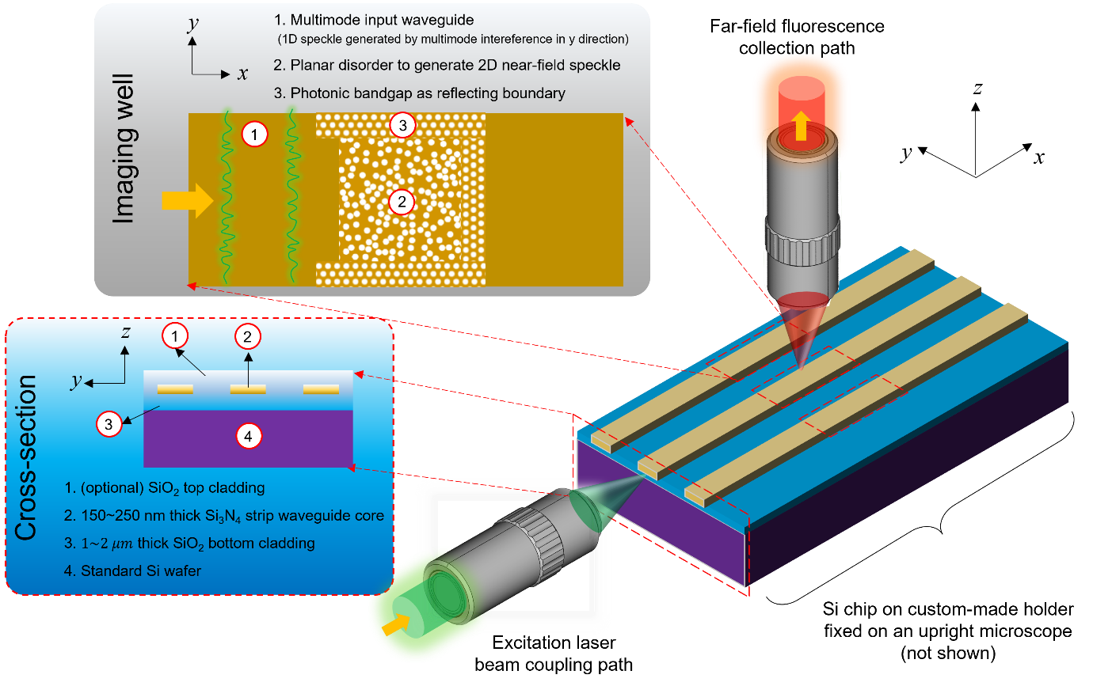
Fig. R36. Chipscopes with a planar disorder proposed to resolve aforementioned practical hurdles and to make NS-SOFI imaging more practically viable imaging system.
The practical bottlenecks discussed in R1.3.4.1 can be mitigated by introducing “chip-scope” configuration as sketched in Fig. R36. Briefly, an illumination objective lens introduce a point spot to multimode waveguides with subwavelength thickness such that waveguiding modes, which are subwavelength-speckled in the transverse direction, propagate to the imaging well, where two-dimensional planar disorder converts propagating waveguiding modes in wide-field near-field speckle patterns. By placing our fluorescent sample on this disordered region, we hope that our NS-SOFI imaging yields more predictable and engineering-amenable performance in a much compact integrated photonics platform, squeezing every bulky illumination optics into a strip of silicon nitride waveguides.
How this newly proposed NS-SOFI chipscope resolves the practical issues discussed in R.1.3.4.1 is summarized in Fig. R37. The novelty of our NS-SOFI chipscope is further highlighted by comparison with other near-field illumination-based super-resolution imaging platform is presented in Fig. R38-39.
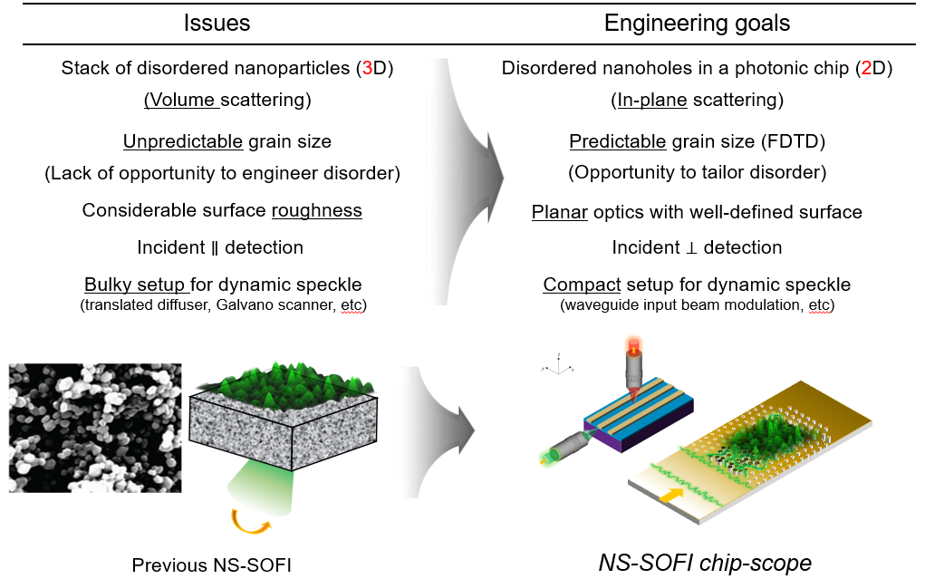
Fig. R37. Visual summary of how the proposed NS-SOFI chipscope resolves practical bottelenecks in the previous NS-SOFI platforms.
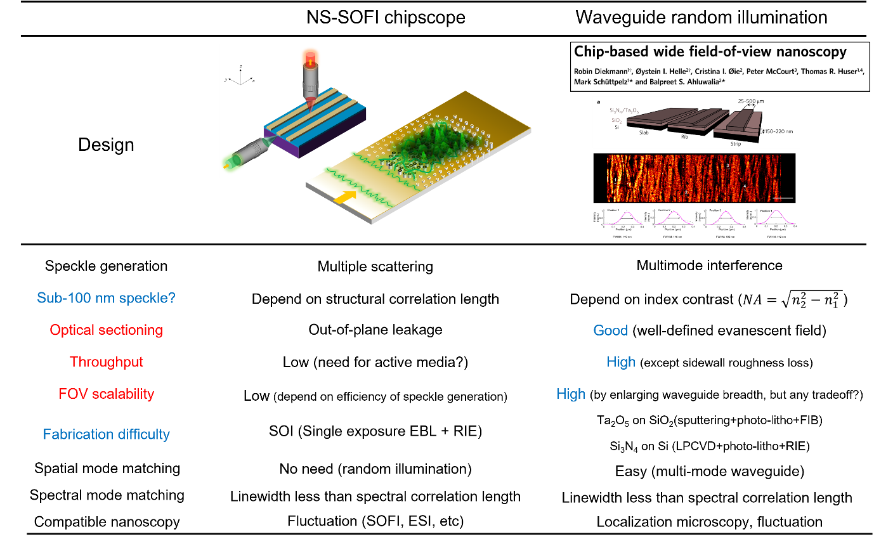
Fig. R38. Comparison of NS-SOFI chipscope and the “chip-based wide field-of-view nanoscopy” platforms.
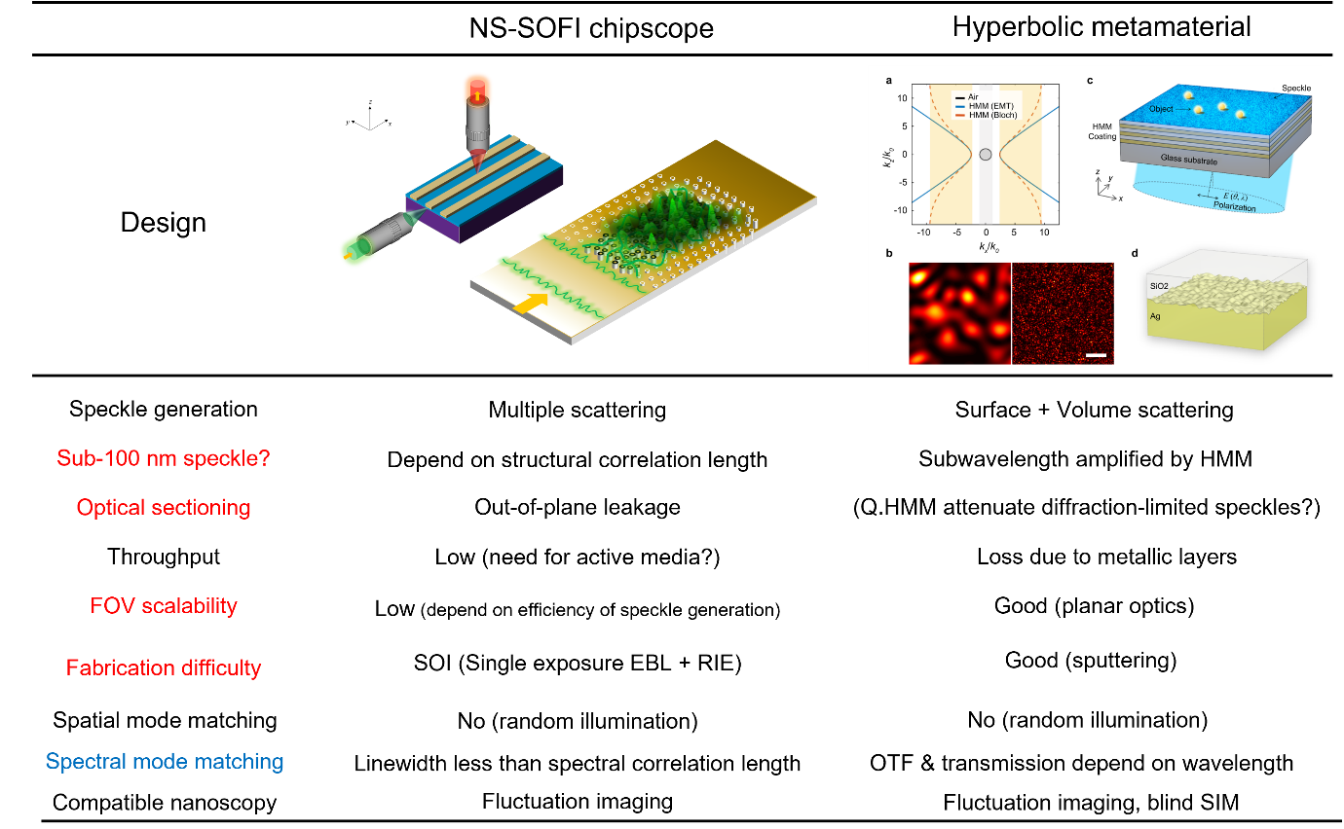
Fig. R39. Comparison of NS-SOFI chipscope and the “speckle-MAIN” platforms.
[Ref. speckle-MAIN] Lee, Y. U., et al. "Metamaterial assisted illumination nanoscopy via random super-resolution speckles." Nature communications 12, 1559 (2021)

R1.4. Improved readability: references to supporting information and revisions on manuscripts.
R1.4.1. Reviewer 1’s comments to be addressed
The authors do not provide any references to the SI, which makes it very hard to follow. Some description of the excitation modality is needed in the main text. Some background about the manner by which substrates are prepared is also necessary.
R1.4.2. Reply to R1.4.1.
Again, we apologize for mistakenly missing important references to Supporting Information while moving the substantial parts of manuscripts into Supporting Information to meet the limit posed by Nano Letters (up to 3,000 words and 5 figures in the main text). As addressed in R1.1., we incorporated the schematic description of excitation modality in Supporting Figure S2 (included in the previous Supporting Information before revision) and the renewed Fig 1. in the previous manuscript to provide sufficient details for understanding our experimental setup to generate dynamic near-field speckle illumination and their consequences after NS-SOFI processing.
To offer background on the preparation of disordered substrates used as both a sample mount and a near-field speckled wavefront shaper, we have added a new Supporting Figure S1 that provides information on the physical properties and composition of the disordered substrates, as shown below:
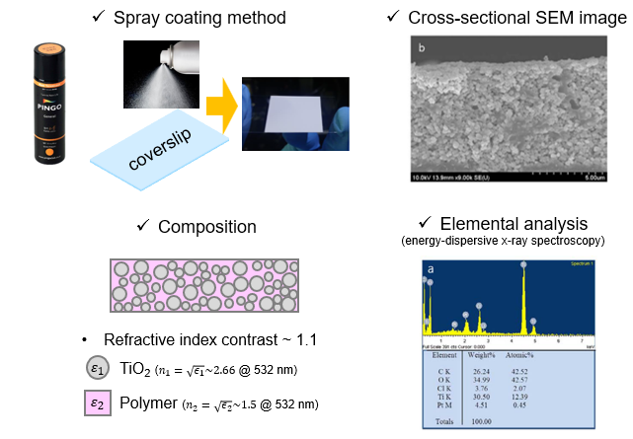
Supporting Figure S1. Detailed information of the disordered substrates used in this study.
R2. Reply to reviewer 2’s comments
R2.1. Description of the physical properties of dynamic near-field speckle illumination.
R2.1.1. Reviewer 2’s comments to be addressed
The authors’ goal is to prove that near-field speckles are preferable to far field ones. This should be of no surprise because it is well-known that in the near field, the spatial correlation length is determined by the properties of the interface rather than the wavelength of light. The authors mention a couple of references but there are many more.
A better literature context is necessary.

R2.1.2. Reply to R2.1.1.
We deeply appreciate the recommendation of references on describing [Ref. 1-12] and exploiting [Ref. 13, 14] the non-universal character of the near-field speckle patterns and the recent techniques demonstrating custom manipulation of the speckle field statistics [Ref. 15-17]. These references are newly added to the main text of the manuscript and cited to give a better literature context.
- Literatures that describe and characterize subwavelength spatial coherence of the speckle patterns in the near-field.
[1] Dogariu, A., & Carminati, R. Electromagnetic field correlations in three-dimensional speckles. Physics Reports. 559, 1–29. (2015).
[2] Apostol, A., & Dogariu, A. Spatial Correlations in the Near Field of Random Media. Physical Review Letters, 91(9), (2003).
[3] Apostol, A., & Dogariu, A. Coherence properties near interfaces of random media. Physical Review E, 67(5), 055601, (2003).
[4] Apostol, A., & Dogariu, A. First-and second-order statistics of optical near fields. Optics letters, 29(3), 235-237. (2004).
[5] Apostol, A., & Dogariu, A. Non-Gaussian statistics of optical near-fields. Physical Review E - Statistical, Nonlinear, and Soft Matter Physics, 72(2), (2005).
[6] Emiliani, V., et al. "Near-field short range correlation in optical waves transmitted through random media." Physical review letters 90, 25, 250801(2003).
[7] Chen, X., Zhang, Y., Han, Y., Rong, Z., Zhang, L., Li, Z., & Cheng, C. Study on the correspondence between random surface topography and its interface speckle field. Optics Communications, 462, (2020).
[8] Henkel, C., Joulain, K., Carminati, R., & Greffet, J. J. Spatial coherence of thermal near fields. Optics communications, 186(1-3), 57-67, (2000).
[9] Roychowdhury, H., & Wolf, E. Effects of spatial coherence on near-field spectra. Optics Letters, 28(3), 170-172. (2003).
[10] Carminati, R. Subwavelength spatial correlations in near-field speckle patterns. Physical Review A, 81(5), (2010).
[11] Parigi, Valentina, et al. "Near-field to far-field characterization of speckle patterns generated by disordered nanomaterials." Optics express 24.7, 7019-7027, (2016).
[12] Naraghi, R. R., Sukhov, S., & Dogariu, A. Disorder fingerprint: intensity distributions in the near field of random media. Physical Review B, 94(17), 174205, (2016).

- Application of near-field speckle patterns for advanced optical characterization of two-dimensional materials via near-field coherent imaging.
[13] Naraghi, R. R., Cançado, L. G., Salazar-Bloise, F., & Dogariu, A. Near-field coherence reveals defect densities in atomic monolayers. Optica, 4(5), (2017).
[14] Cançado, L. G., Naraghi, R. R., & Dogariu, A. Passive near-field imaging with pseudo-thermal sources. Optics Letters, 42(6), 1137. (2017).

- Demonstration of techniques to custom-control the statistics of complex light.
[15] Bender, N., Yılmaz, H., Bromberg, Y., & Cao, H. Creating and controlling complex light. APL Photonics, 4(11), 110806, (2019).
[16] Bender, N., Yılmaz, H., Bromberg, Y., & Cao, H. Customizing speckle intensity statistics. Optica, 5(5), 595-600, (2018).
[17] Bromberg, Y., & Cao, H. (2014). Generating non-Rayleigh speckles with tailored intensity statistics. Physical Review Letters, 112(21), 213904.
R2.2. Fluorescence fluctuation dynamics induced by dynamic near-field speckle illumination: intensity statistics and its implication on the spatial resolution of the final NS-SOFI image.
R2.2.1. Reviewer 2’s comments to be addressed
The first question I have relates to the experimental setting shown in Fig1. How are the NF speckles generated? What is the “turbid medium”? What are its “turbid” properties? What they insure that only “subdiffraction” components contribute to what is measured in the NF? Does the probe itself affect the measurement? There are many practical aspects that can modify a measured correlation function.

R2.2.2 Reply to R2.2.1. a. Definition of “turbid medium” and its physical properties

Supporting Figure S1. Detailed information of the disordered substrates used in this study.
First, we apologize for your confusion on our terminology, and in our manuscript, the term ‘turbid medium’ is equal to the ‘disordered medium’. To avoid this confusion, we’ve avoided the usage of ‘turbid’ in the revised manuscript and Supporting Information and used the only the expression ‘disordered’.
To provide enough details on the disordered substrate that act as both wavefront shaper in the near-field and the sample mount, we have added a new Supporting Figure S1 to provide the detailed information of the disordered medium used in this study, which is identical to the samples in our previous work [Park, J. H. et al. Nat. Photonics 7, 454–458 (2013)]. The sample preparation procedure is described in the Supporting Note S1, which is partially reproduced here.
“Supporting Note S1. Sample preparation of disordered substrates and characterization of near-field speckle patterns. We spray commercial Pingo paints (Pingo general, Noroo paint, Korea) on a target sample pre-mounted on a coverslip to deposit a turbid layer of TiO₂ dielectric nanoparticles as described in Ref. 1, 2 (References for Supporting Information). The TiO₂ turbid layer must have a thickness of at least a few multiples of the mean free path in the paint to ensure that sufficient scattering occurs.(omitted)”

R2.2.3. Reply to R2.2.1. b. “What they insure that only “subdiffraction” components contribute to what is measured in the NF? Does the probe itself affect the measurement? There are many practical aspects that can modify a measured correlation function.”
First, subwavelength correlation length demonstrated in Fig. 2d is only possible when both propagating and evanescent Fourier components contribute to the speckle patterns measured in the near-field by collection mode NSOM. The effect of finite aperture of NSOM probe was not deconvolved in the measured spatial autocorrelation function of Fig. 2d, which gives upper limit of the near-field speckle grain size, as described in the main text as follows :

“Figure 2d presents the two-dimensional spatial autocorrelation image of the near-field speckle pattern in Fig. 2c. The full-width-half-maximum (FWHM) of the autocorrelation in the inset graph of Fig. 2d, or equivalently short-range correlation length of spatial intensity distribution, provides an estimate of the minimum grain size of the near-field speckle patterns patterns⁴². The cross-sectional profile shows that our near-field speckle patterns have a correlation length of 150 nm significantly smaller than the half wavelength of the excitation laser. The actual correlation length can be even smaller than the measured value (150 nm) as no correction is applied to take into account of additional blur caused by the finite aperture size of the NSOM tip (see Supporting Note S1 in Supporting Information).”

R2.2.3. Reviewer 2’s comments to be addressed
Second, how is the dynamics created? The NF data shown in fig 2c corresponds to a stationary situation I guess. How fast can this dynamics be and how is it measured?
R2.2.4. Reply to R2.2.3. How dynamic near-field speckle illumination is generated and induce fluorescence intensity fluctuation (see the renewed Fig. 1)

(Revised) Fig. 1. Dynamic near-field speckle illumination for NS-SOFI imaging experiment. a, b. Two independent fluorophores are assumed to be separated within subdiffraction distance under dynamic speckle illumination in the far- (a) and near-field (b). Examples of fluorescence intensity fluctuation trace I(r,t) measured during 300 frames of dynamic speckle illumination sampled at the locations of the two fluorophores and their midpoint. In contrast to far-field speckles (a), dynamic near-field speckle illumination (b) of subwavelength grain size produces independent fluctuation of two fluorophores favorable for SOFI processing. Here, the transparent Gaussian lobes assigned to each fluorophore represent the scale of the point spread functions of the base fluorescence detection imaging system. c, d Schematic representation of illumination optics to produce dynamic near-field speckle illumination. A pair of (pseudo-colored) red and blue sphere describes two independent fluorophores separated within subdiffraction distance under dynamic near-field speckle illumination. d Pictorial description of two-step scattering of a laser beam through the translated diffuser and turbid medium, which results in dynamic near-field speckle illumination at the sample plane (see Supporting Note S2 for details)
I(r,t)

As reviewer #1 pointed out (see R1.4.1.), we deeply apologize for lack of clarity by mistakenly omitting our description of excitation modality to generate dynamic near-field speckle illumination in the manuscript while compressing our main text to meet 3,000 words limit newly imposed by Nano Letters in 2020. Supporting Figure S2 (now incorporated into Fig. 1 in the revised manuscript) provides graphical illustration of how dynamic near-field speckle illumination is generated by two-step scattering through a translated diffuser and a disordered medium. We reproduce the Supporting Note 2.1. (and part of them moved to main text of our manuscript describing Fig. 1c, d) below that describes this process with enough details.

“Supporting Notes S2.1. Method to generate dynamic near-field speckle illumination at the sample plane. As a simple means to generate the dynamic near-field speckle patterns exploited in our experiment, a disordered layer of white spray paint comprising TiO₂ nanoparticles and fixative polymer plays a dual role of a sample mount and wavefront shaper for near-field speckles as in Fig. S2a, which is depicted with overall layout of fluorescent microscopy setup in trans-illumination geometry. Figure S2b, c provides illustration of two-step scattering process for intuitive description of how a collimated laser beam turns into dynamic near-field speckle patterns through illumination optics system in Fig. S2a. First, dynamic far-field speckle patterns [$FS\left(r,x\right)$, $r$ denotes the two-dimensional coordinates located at the sample plane and $x$ assigns a position coordinate of the diffuser] are produced when a collimated laser beam is scattered by a translating diffuser³. Next, these dynamic far-field speckle patterns enter the turbid medium after propagation through far-field lens system (depicted as $L1$,$L2$) and are scattered again within the turbid medium, thus turning into near-field speckle illumination [$NS\left(r,x\right)$] at the sample plane. Dynamic variation of the near-field speckle patterns is due to independent far-field speckle patterns varying in sync with the movement of the diffuser ($x_{0}→x_{0}+Δx→x_{0}+2Δx$as in Fig. S2c).“

R2.2.5. Reviewer 2’s comments to be addressed
Related to this, the statistical field distribution is particularly nongaussian in NF (see for instance PRE 72, 025602 2005 or more recently Opt. Comm 462, 125308, 2020). The authors should discuss this in the context of their spatial resolution.
R2.2.6. Reply to R2.2.5. c. Intensity statistics of employed dynamic near-field speckle patterns and their implications on super-resolution imaging performance
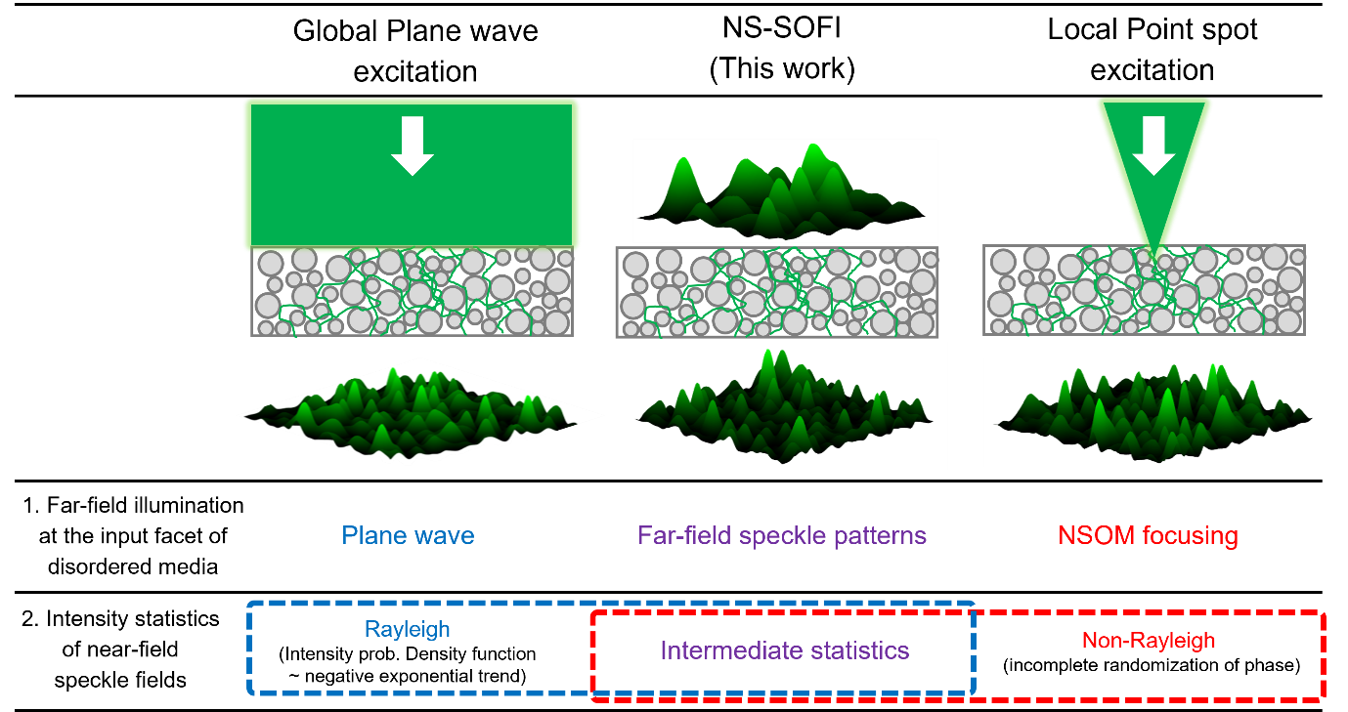
Fig. R40. Intensity statistics of near-field speckle patterns under different excitation conditions. For global and local excitation, we cited the intensity statistics as reported in the PRE 72, 025602 (2005). Intensity statistics under far-field speckle illumination, which is the case for this study, is hypothesized to exhibit intermediate between two extremes, Rayleigh and Non-Rayleigh intensity probability density functions.
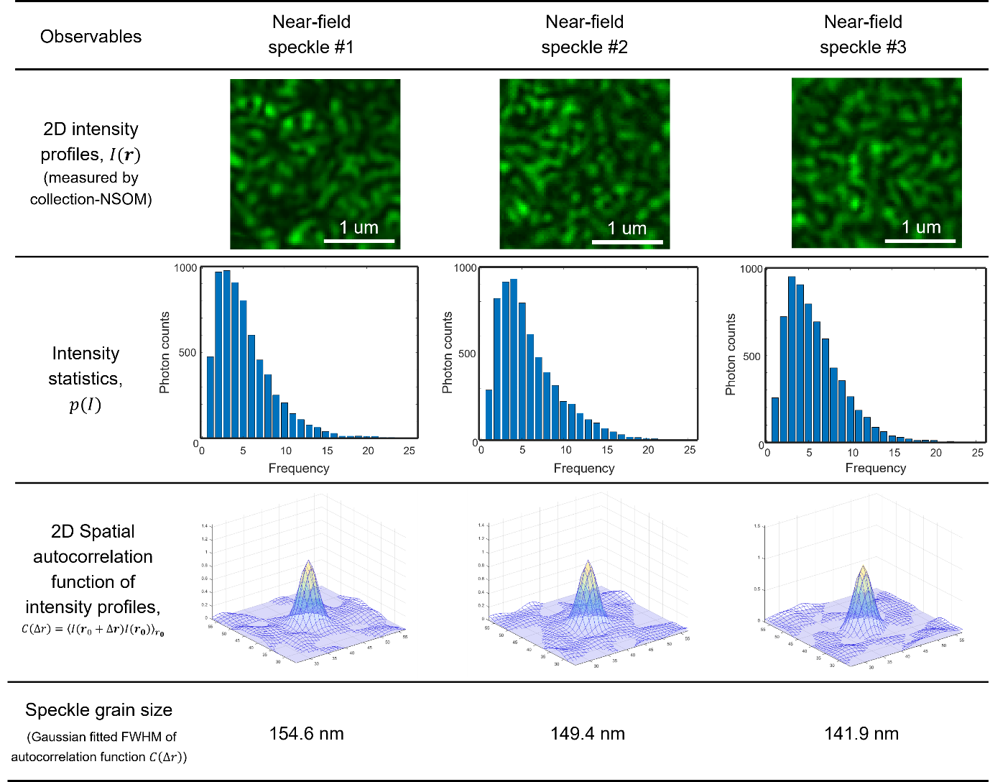
(Newly added as Supporting Figure S2.2.) Fig. R41. Intensity statistics of three representative stationary near-field speckle patterns having nearly 150 nm grain size under far-field speckle excitation conditions.

Though we have checked the deviation from Rayleight statistics of our near-field speckle patterns as shown in Fig. R41 (newly added as Supporting Figure S2.2), we’ve found that the most important intensity statistics of speckle illumination that directly translates to the final super-resolution is the speckle grain size, not the type of the statistics. This remark is newly added in the main text of our manuscript regarding Fig. 2d, as follows:

“…This subwavelength-scale grain size is the unique feature of near-field speckle patterns whose correlation length is driven by the microstructure of the scattering medium, not by the wavelength of the scattered light¹⁹⁻³⁵. Unlike far-field speckle illumination with complex field exhibiting Rayleigh statistics, though dynamic near-field speckle illumination employed for NS-SOFI deviates from Rayleigh statistics (see Supporting Figures S2.2.)¹⁹⁻³⁵, the intensity statistics of speckle illumination that directly translates to the final super-resolution is the grain size, not the type of the speckle field statistics.”

R2.3. Comparison with other imaging modalities employing near-field illuminations.
R2.3.1. Reviewer 2’s comments to be addressed
Finally, the authors should also discuss their fluorescent scheme in relation to previous demonstrations of improved near-field imaging that all rely on random fields and their sub-wavelength extent of spatial coherence (see for instance OL 42, 1137, 2017 or Optica 4 527, 2017).

R2.3.2. Reply to R2.3.1.
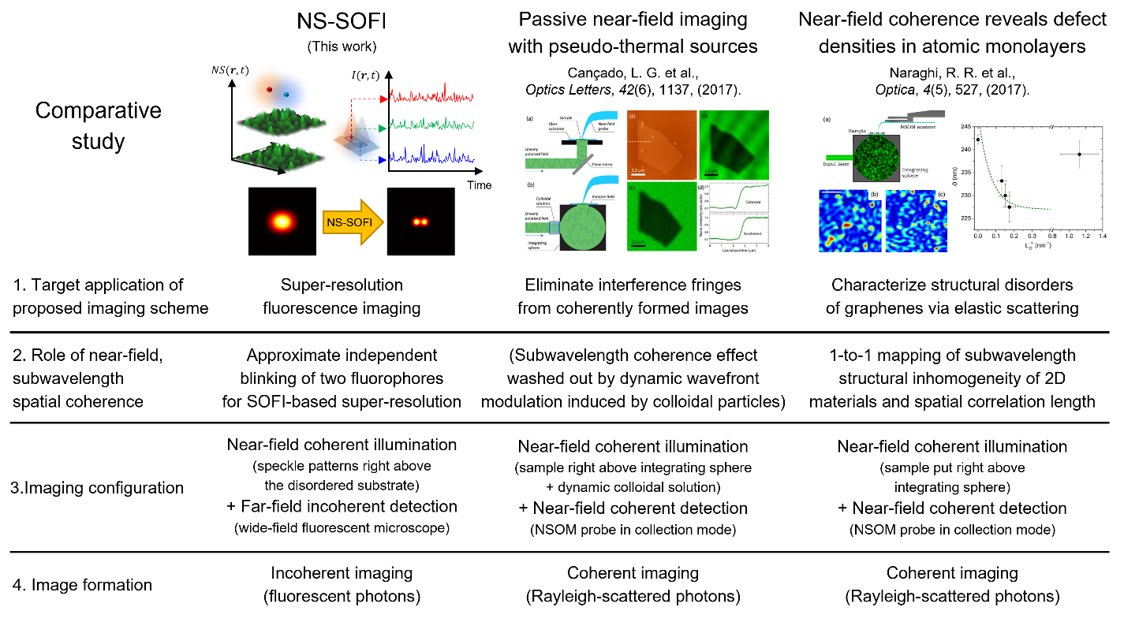
Fig. R42. Comparison of NS-SOFI with other near-field illumination microscopy applied to optical characterization of two-dimensional materials.
We appreciate for recommending intriguing recent examples of employing near-field speckle illumination for optical characterization of the two dimensional materials. We’ve carefully reviewed the recommended references (OL 42, 1137, 2017 or Optica 4 527, 2017) and made a comparison chart as shown in Fig. R42 to discuss the different applications of subwavelength spatial coherence produced in the near-field of disordered media.
The first notable difference of our NS-SOFI scheme and the coherent modalities suggested in OL 42, 1137, 2017 and Optica 4 527, 2017 is that the manner by which the effect of subwavelength coherence is detected. As we didn’t use NSOM in actual NS-SOFI imaging, we have no means of directly probing the subwavelength spatial coherence of the employed near-field speckle patterns. The only observable in our NS-SOFI scheme is the fluorescent images under dynamic near-field speckle illumination. Subwavelength spatial correlation length of near-field speckle patterns translates to the final SOFI resolution, from which we indirectly judge whether near-field speckle patterns indeed excited our fluorescent sample or not.
In contrast, both OL 42, 1137, 2017 and Optica 4 527, 2017 implement collection NSOM to directly probe the intensity of near-field speckle patterns. In these cases, subwavelength spatial correlation length is direct observable of the imaging setup. As NS-SOFI have no near-field detection module, subwavelength spatial correlation length is indirect observable quantity.
What is common for the three near-field illumination microscopes is that their effective volume is limited to the very thin sample such as two dimensional materials, which can be directly exposed to near-field speckle patterns if place right above the integrating sphere or our disordered substrates. As near-field speckle patterns lose their subwavelength information quickly upon far-field propagation of few tens of nanometers, optical characterization of two dimensional materials are ideal applications for both our NS-SOFI and suggested OL 42, 1137, 2017 and Optica 4 527, 2017. We hope that these works inspire the surge of interest in intriguing applications of subwavelength spatial coherence for characterizing “fascinating flat lands” of two-dimensional nanomaterials.

